





**Abstract**

With the development of digital technology, the culinary industry has experienced a revolutionary change, providing a wide range of cooking tools and experiences. To meet the changing needs and preferences of modern food enthusiasts, the creation of cooking recipe applications has emerged as a significant trend. This abstract explores the conceptualization, design, and unique elements of a cooking recipe app, highlighting how it might alter how people interact with the culinary arts.

The cooking recipe app smoothly combines functionality, engagement, and convenience in what is intended to be an all-encompassing and user-focused platform. The app strives to offer users an effective and motivational gastronomic experience in today's fast-paced, time-constrained environment. The app offers complete support to a broad range of users, taking into account their unique experience and objectives, from novices looking for step-by-step instructions to seasoned chefs looking for creative concepts.The app's main highlight is the wide range of recipes, which cover a variety of cuisines, dietary preferences, and skill levels. The interface places a high priority on usability, ensuring simple navigation and quick access to recipes. The use of video content, which offers viewers engaging culinary demos that not only deepen learning but also develop confidence in the kitchen, is a distinguishing feature. These video presentations add visual appeal and interesting clarity while enhancing the user experience when combined with high-quality photos.

The app uses user search data and information from sources like Google Analytics, which is powered by cutting-edge technology, to provide intelligent recipe recommendations. A genuinely personalised experience is achieved by customising recommendations to individual preferences, including dietary restrictions, ingredient availability, and previous user interactions. The application also promotes a sense of community through its interactive features. Users can share their recipes, adaptations, and suggestions, providing a dynamic and collaborative environment where foodies can interact and find inspiration from one another.

The app's technical architecture, which uses Firebase for backend infrastructure and React for frontend development, promises resilience. Real-time updates, faultless performance, and effective data management are all made possible by this combination. The iterative development method ensures a flawless user experience, especially when combined with thorough testing. The app's ability to get frequent updates further emphasises its flexibility in responding to changing user demands and fashion trends.

Even if it hasn't included all of the features that were originally anticipated, the project has been a big undertaking. Throughout the development process, we had a number of difficulties that we successfully and partially overcame. We carried out module testing in the phases after development to make sure the website functions properly.

The main goal of this project is to develop a platform where chefs may experiment with new recipes, publish their results with the general audience, and do both. It involves creating a vibrant community of fervent foodies.

In conclusion, the cooking recipe app presents a fresh viewpoint on the evolution of cuisine in the digital age. It functions as a trustworthy companion for both inexperienced and experienced cooks by integrating user-centric design, interactive aspects, and cutting-edge recommendations. Its creative use of personalised recommendations and video content marks a break from traditional recipe platforms and embraces dynamic learning and engagement. This software emerges as a revolutionary force in the changing culinary world, enabling users to discover, create, and enjoy the art of cooking in new ways.

**Declaration**

I am hereby certified that this report constitutes my own work,that where the language of others used,quotation marks so indicates,and the appropriate credit is given where I have used the language,ideas,expression or writings of others.

I declare that this report describes the original work that has not been previously presented for the award of any other degree of any other institution.

Signed

Febin Eldhose

**Date:** 06.09.2023

**Acknowledgments**

I would like to express my heartfelt gratitude to the individuals who have played pivotal roles in the development and success of my Cooking Recipe Website project.

First and foremost, I want to extend my sincere appreciation to my project supervisor, **Mr. Kuo-Ming** sir. Your guidance, mentorship, and unwavering support have been invaluable throughout this journey. Your expertise has significantly contributed to the growth of my knowledge and skills in web development.

I would also like to acknowledge **Mr. Robbin paps**, my supporting teacher, for his guidance and assistance in both the development and management of the website. Your insights have been instrumental in shaping the project's direction.

A special note of thanks goes out to my friends **Abhilash** and **Rahees** who dedicated their time and effort to testing the website. Your feedback was instrumental in identifying and resolving issues, ensuring that the website offers a seamless experience to its users.

Lastly, I want to express my deep appreciation to all those who have contributed to this project in various ways. Your collective efforts have helped bring the Cooking Recipe Website to life.

This project has been a rewarding experience, and I am grateful for the support and encouragement I have received from everyone involved. Thank you for being a part of this exciting culinary journey.

Sincerely,

Febin Eldhose

Table of Contents

**Chapter 1: Introduction to the Project** **7**

Aims 8

Objectives 8

Project Breakdown 8

**Chapter 2 : Risk and issues** **10**

**Chapter 3 : Background** **12**

**Chapter 4 : Literature Review** **13**

**Chapter 5 : Technology Review** **18**

Technologies reviewed 18

Technologies Used for Cooking Recipe app 21

**Chapter 6 : Methodology** **24**

Project Management 24

**Chapter 7 : Project Lifecycle** **28**

Plan stage 30

Design Stage 31

User persona 31

User Journey Map 32

User Stories 34

Flow Diagrams 35

WireFrames 36

Testing Stage 46

**Chapter 8 : Results** **50**

Evaluation 50

**Chapter 9 : Conclusion** **52**

Reflection 52

Future Work 53

**References** **54**

# Chapter 1: Introduction to the Project

In today's culinary landscape, the food trend is on the rise, and cooking enthusiasts are passionate about their craft.They may encounter a creativity block, struggling to come up with fresh and intriguing dishes to test, especially when catering to specific dietary recommendations like vegan, vegetarian, gluten-free, and more. To expand their culinary horizons, they seek new inspiration and direction.Furthermore, even if cooking enthusiasts are familiar with a recipe, they often lack knowledge about the specific ingredients and tools required to successfully recreate that particular dish. This lack of familiarity can hinder their ability to execute the recipe accurately and achieve the desired outcome.Moreover, planning recipe ingredients can be a challenge for cooking enthusiasts. They may require assistance in organising and gathering the necessary ingredients, particularly when adhering to specific dietary preferences.

This project will help to overcome those challenges faced by the cooking lovers and also this website will provide a better user interface for the users to explore the cooking journey. The report here includes the situations where the idea forms,some user interface implementations,prototypes(blue print),design steps,usability testing reviews and some future implementation plannings.In this plan of cooking we only focus on the users and their meal interests.

To address the various challenges faced by cooking enthusiasts, we are planning to develop a comprehensive website that combines multiple solutions into one platform. While there are existing applications that tackle some of these issues, none offer all the necessary features. This project aims to provide a holistic solution.

One significant improvement plan to introduce is a new feature called "Reels Mode." In the current scenario, users often have to read through the entire recipe to understand the cooking process, which can be time-consuming and challenging. By implementing Reels Mode, users can watch short, engaging video clips that showcase the recipe steps. This visual format is more captivating and appealing, increasing user interest and participation.From the first stage of coming up with meal ideas, implementation, testing, debugging, and potential future improvements, this report gives a thorough picture of the project flow. It describes every step in detail and emphasises significant details and project milestones.

## 

## Aims

1.To create a platform that will help cooking enthusiasts to explore and create the recipes hub.

2.User will get recommended recipes to their preferences.

3.Help to plan the meals and groceries.

4.To debug the whole application and performance.

## Objectives

1.Users need to publish their own recipes and they will get feedback

2.User need to get new recipe videos/tips with a smooth user interface.

3.User will get auto suggestions for their recipe preferences.

4.Users will get better recipe ingredient planning.

5.To research on better web application performance.

## Project Breakdown

**Chapter 2 :** In this section, we'll examine the substantial effects that legal compliance, data gathering methods, and privacy policy restrictions have on the web application development cycle. These factors are all crucial for upholding compliance and protecting user data.

**Chapter 3:**In the following section, we will explore the context in which this website holds significance for its users.

**Chapter 4.**In this section, we will discuss the literature review and an evolution of the idea.

**Chapter 5.**In this section, we will discuss the process of selecting the most suitable technology for web development and the approach to assess available choices, considering their individual benefits and drawbacks.Lastly, choose the best option for the project development.

**Chapter 6**:In the following section, we will delve into earlier research and progress concerning this subject, covering areas such as user-generated recipe creations,recipe exploration,challenges faced on development and customised recipe recommendations.

**Chapter 7**:This is the main part and this section will explore the comprehensive project structure and life cycles. It will encompass the entire implementation process, along with user experience visualisation through wireframes, depicting the complete user flow during the cooking journey.

**Chapter 8**:A thorough project evaluation is carried out in this section, including a review of overall progress and a determination of whether the current state of the project is in aligned with the original aims and objectives.

**Chapter 9:**This part will explore a thorough project reflection and lay out potential directions for advancement and improvement in the future.

# Chapter 2 : Risk and issues

A range of possible risks and challenges are introduced when creating a website with cooking instructions, and developers must be prepared to address them. These difficulties include a wide range of topics, from complex technical details to user experience concerns. Here are a few crucial things to think about:

**Data privacy and policy**: Strong security protocols must be put in place in order to protect personal information, such as user preferences and dietary information, against unauthorised access, breaches, and potential exploitation[10]. Maintaining user privacy requires adherence to data protection laws like GDPR or HIPAA (if applicable).

**Content accuracy and authenticity:** Accuracy and validity of the content are essential in a website with cooking recipes. Users may be disappointed by inaccurate or deceptive recipes, which could damage the platform's reputation. Curating content from trustworthy sources is essential to uphold user trust. By making sure that the recipes are accurate and reliable, the website becomes known as a reliable source for culinary advice, which raises customer happiness and engagement[10].

**User Generated Content Moderation:**Cooking recipe websites are made more interactive by incorporating user-generated content, but this also brings with it the difficulty of maintaining content quality. Allowing users to submit recipes exposes the platform up to the possibility of low-quality content, which might damage its reputation[10]. To solve this, we need effective content moderation systems. These processes efficiently sift supplied content, locating and eliminating spam, objectionable information, and irrelevant submissions. By ensuring that the material adheres to the website's standards, a positive user experience is maintained. By carefully enforcing moderation, the site not only protects against offensive content but also fosters an environment where users can trade and explore recipes with confidence, strengthening a sense of community participation.

**Cross-Browser Compatibility:**Cross-browser compatibility is a challenging technological challenge that requires the website to function correctly on a variety of browsers and devices. The user experience might be negatively impacted by rendering irregularities, needing careful testing and precise modifications to ensure flawless performance.

**Performance optimization:**Users may become discouraged by slow load times. The optimisation of pictures, code, and server responses to ensure quick speed is crucial to preserving a seamless and responsive user experience.

**Recipe variability:**Due to the wide range of tastes, dietary requirements, and preferences of users, allowing for recipe diversity is essential. It is crucial, albeit challenging, to develop search and filtering systems that recognise this variability. Users want solutions that are specifically tailored to their culinary preferences and constraints. In order to satisfy this demand, a system that efficiently arranges and displays recipes must be created, taking into account factors like ingredients, cuisine styles, and dietary requirements. These systems increase customer satisfaction by making it easier to find recipes that are specific to their needs. As a result, they foster greater user engagement with the website's content and promote prolonged interaction times.

**Legal and Copyright Issues:** Managing legal and copyright aspects is essential while disseminating recipes. Misusing or not crediting recipes can result in copyright violations. It's vital to appropriately acknowledge sources and seek permissions when necessary to avoid legal complications[10]. Recipes, as creative content, are subject to intellectual property safeguards. Ensuring proper treatment upholds creators' rights and legal compliance. This approach safeguards against legal repercussions and underscores ethical conduct. It highlights reverence for original creators, fostering a responsible digital realm that's both reputable and considerate of culinary enthusiasts' interests.

**Memory issues:** Memory-related challenges can detrimentally impact the functionality of cooking recipe websites, leading to a suboptimal user experience. The presence of sizable image files, extensive databases, and intricate interactions can strain server capacities, resulting in sluggish loading times and system crashes. Inadequate memory management could impede swift recipe access, frustrating users. Mitigating these concerns demands the adoption of streamlined coding practices, effective caching mechanisms, and optimized data storage solutions. Integration of content delivery networks (CDNs) and adaptable hosting services can mitigate memory constraints. Maintaining vigilant oversight and routine upkeep is critical to thwart memory leaks and ensure seamless navigation. Overcoming memory-related hurdles guarantees users an uninterrupted exploration of recipes, elevating overall website satisfaction.

## 

## 

## 

## 

## 

# Chapter 3 : Background

The idea for developing a website with cooking instructions came from observations made on social media sites and personal experiences. It was clear that many foodies, like myself, had trouble sharing their delectable dishes and culinary prowess with the general public. Furthermore, there were few websites that provided personalised recipe recommendations and suited to certain dietary preferences.

One of my friends, a talented and eager cook, encountered difficulties when trying to learn new cooking techniques from experienced chefs. He found traditional written content on recipe websites to be tedious and less interesting while using social media platforms to keep up with recipes. He emphasized how appealing video content is because it arouses genuine attention as well as curiosity.

As a consequence, the concept of creating a culinary recipe website with a "reels mode," mostly centered around recipe content that is video-based, emerged. This strategy will provide viewers with visually appealing and fascinating recipe videos, removing the need to browse through numerous social media sites in search of culinary inspiration. The website's main goal is to boost user engagement and provide individualised service in a straightforward and user-friendly way.

The envisioned website would act as a focal point where cooking lovers could display their talents, share delectable recipes, and interact with like-minded people. Users would have access to a wide range of recipes, instruction from top chefs, and a platform that allows them to customise their culinary experiences according to their individual dietary needs and interests.

The website aspires to develop an active and engaging community of food enthusiasts by incorporating user-generated video recipes alongside curated gourmet information. Users would be able to communicate, provide cooking advice, and encourage one another to try out new delicious foods.

In conclusion, the concept for the cooking recipe website with a reels mode was inspired by my personal experiences , underlining the difficulties that food aficionados encounter in finding interesting and unique dishes. The intended site, which will emphasise video content, intends to increase user engagement, encourage culinary experimentation, and establish itself as the go-to place for people starting an inspiring and fun cooking adventure.

# 

# Chapter 4 : Literature Review

Cooking recipe web applications have seen a noticeable increase in popularity in recent years. These platforms give consumers a simple and convenient way to explore, find, and share a variety of culinary recipes. This literature review will focus on the key features, user interface, technological developments, and difficulties that cooking recipe web applications have to tackle. This review will throw light on the important factors that contribute to the success of these platforms by analysing current research and studies. It will also go through the technological developments that have influenced the design of these applications, as well as the difficulties that have been encountered in terms of user engagement, content quality, and legal issues. This literature review analyses these elements in an effort to give readers a thorough grasp of the state of cooking recipe online applications today and to suggest potential directions for further study and development.

1.User Experience and Engagement:

Cooking has expanded beyond the confines of traditional cookbooks as online recipe websites have become important gathering places for foodies looking for both inspiration and direction. The effectiveness of these platforms depends heavily on providing a faultless user experience (UX) and encouraging high levels of participation in this digital age. The foundation of a top-notch cooking website is a seamless user experience (UX) that melds clear instructions, simple recipe accessibility, and intuitive navigation. But developing a winning recipe for success requires more than simply functional design; it also calls for a combination of compelling content, engaging features, and personalised recommendations.

The crucial roles that UX and engagement play in the world of cookery websites have been astutely identified by academics. Choo and Park (2020) stress the importance of clear recipe structures, high-quality graphics, and intuitive design layouts. These elements not only make it simple to understand recipes, but they also improve the browsing experience as a whole. On top of this foundation, Chen et al. (2019) explore the importance of personalising recommendations depending on specific user preferences and dietary restrictions. Users' loyalty to the platform is strengthened by this personal dimension, which also helps them find useful recipes.

According to Salmon (2018), incorporating social elements like user-generated content and community interactions can further enhance user engagement, a critical metric for success. Users feel a sense of community and belonging because to the ability to share experiences, advice, and variants, transforming the platform into something other than a simple recipe database. Furthermore, according to Danciu et al. (2017), interactive features like cooking timers and step-by-step video tutorials improve the UX by guiding users through challenging recipes and boosting their confidence in the kitchen.

In conclusion, the secret to increased engagement and contentment on cooking recipe websites lies in a user-centred strategy that smoothly combines personalised recommendations and interactive elements. These platforms transform into hotbeds of culinary innovation by customising material to suit individual tastes, dietary requirements, and skill levels. Additionally, the addition of interactive components enhances the UX and gives consumers the confidence to confidently set off on culinary odysseys. The line between a simple website and an immersive epicurean adventure blurs as visitors get involved in a community of like-minded gourmands.The end result is a carefully balanced combination of elements—a symphony of design, utility, and community—that connects strongly with people and entices them to keep using it. In summary, a cooking website succeeds when it can provide not only recipes but also an enriching, illuminating, and exhilarating experience.

2.Personalized recipe recommendations:

In 1979, the recommendation system concept was first introduced through Grundy, a computer-based librarian that offered book recommendations to users[8].The introduction of this early application signalled the start of the development of sophisticated recommendation technologies, which are currently essential across a variety of businesses.Personalised suggestions are delivered by recommendation systems using a variety of techniques. In order to identify similarities between users or objects and provide pertinent recommendations, collaborative filtering analyses user-item interactions. On the other side, content-based filtering makes recommendations based on qualities and user preferences. Hybrid strategies combine the two methods to improve accuracy. Complex recommendation tasks are handled by integrating cutting-edge technologies like matrix factorization, deep learning, and natural language processing. By directing customers to products, content, or services that match their interests and requirements and create a more gratifying and engaging user experience, these systems play a crucial role in decreasing information overload.

In recent years, numerous food recommendation systems have been put forth to forecast people's preferences and/or direct their choices based on predetermined criteria (Gao et al., 2019, Gao et al., 2022, Toledo et al., 2019, Trattner and Elsweiler, 2017).

Main two limitations of previous recommendation system are,

1.Healthy Recommendations

Earlier food recommendation systems (Gao et al., 2019, Gao et al., 2022; Mehrdad Rostami, et al., 2022) primarily focused on user preferences, lacking the capability to ensure that the recommended foods are healthy choices for consumers. These systems did not effectively consider the health and nutritional aspects of the recommended foods.

2.Food Ingredients

The majority of food recommendation algorithms that have been previously published (Pecune et al., 2020; Trattner and Elsweiler, 2017) have been based mostly on past ratings;This strategy ignores ingredients and employs a collaborative filtering process.

But our approach gives special consideration to the food's ingredient composition and health aspect.To make it simple for users to choose their preferred products from the many options available, recommender systems have recently become popular in a variety of real-world applications (Forouzandeh et al., [Deldjoo et al., 2021](https://www.sciencedirect.com/science/article/pii/S0957417423002208#bb0065); Yao et al., 2018; Q. Zhang, Lu, & Jin, 2021). In order to accurately forecast a user's future preferences, recommender systems rely heavily on the preferences of previous users (Forouzandeh et al., 2020; Ruffo and Schifanella, 2009).

So our new RSs are made to provide individualised ideas based on a user's dietary habits, preferred recipes, and personal preferences. These systems' main objective is to assist users in forming healthier eating habits that suit their individual preferences. However, the nutritional and physiological benefits of the recommended foods are frequently ignored by existing food recommendation systems. As a result, they are unable to offer comprehensive, healthful advice, which prevents consumers from significantly altering their diets.We need to resolve these unstable issues through this cooking assistant app.

Cooking recipe recommendation systems are also helpful tools for people looking to expand their culinary horizons, improve their cooking abilities and also for their meal planning. These systems(RS) enable users to experiment with trying new meals by offering recipe suggestions that are customised to their tastes and preferences, thereby improving their cooking experience.

Finally, cooking recipe suggestion systems combine cutting-edge algorithms and machine learning techniques to give a wide range of personalised recipes, making it easier to find mouthwatering culinary options that match users' dietary requirements and cooking preferences.

3.Social Sharing and Interaction:

Web applications for cooking recipes with a social component make a significant contribution to user interaction and the sharing of culinary skills. Users value the chance to connect with other users, contribute their own recipes, and take part in conversations and comments (Volkova et al., 2019). The platform's community-driven features, such as recipe ratings, reviews, and user-generated material, promote credibility (Micheal G.christel et al., 2009). Users can take advantage of these features to actively participate in the community, make relationships, and gain knowledge from the experience of other cooking experts. Cooking recipe online applications stimulate social connections and open up channels for knowledge sharing, creating a thriving community where users may improve their culinary experiences.

4.Technological Advancement

The development of cooking recipe online applications has been significantly influenced by the advancement of technology. Users can interact with recipes hands-free and receive real-time cooking instructions thanks to integration with smart home devices, voice recognition systems, and Internet of Things (IoT)-enabled kitchen appliances (Stankovic, John., 2014). Additionally, automatic recipe parsing, ingredient detection, and extraction from various sources are made possible by the application of computer vision and natural language processing algorithms (Y. Akazawa et al., 2011). Through seamless interactions and effective recipe utilisation, these technical innovations improve the usability and accessibility of culinary recipe web applications.

5.Data collection

There are numerous ways to collect data for a cookery website. Encourage users to participate by submitting their own recipes, images, and reviews as one strategy. Another approach entails setting up a registration system to record user preferences and keep tabs on their culinary activities. By tracking user behaviour, such as recipe views, search queries, and engagement metrics, web analytics tools can offer valuable information. You may learn more about user preferences and satisfaction by using surveys and feedback forms. The website's recipe database can be improved by working together with external data sources, such as food databases or nutrition APIs. Prioritising data privacy and abiding by applicable laws are essential while getting user consent for data collection and usage.

6.Challenges and Limitations

Cooking recipe online applications have many benefits, but they can have issues and are restricted. Maintaining the dependability , quality of user-generated material and database storage space is a critical challenge that calls for effective content filtering and moderation systems (S. Alcic et al., 2011). These applications must take into account important factors such as protecting data privacy, abiding by copyright laws, and managing liability issues with regard to recipe accuracy and user safety (Edwards-Stewart, et al., 2019). For recipe recommendation systems, it can be difficult to accommodate different dietary choices, allergies, and cultural constraints. These difficulties emphasise how crucial it is to put strategies and technology in place to guarantee content integrity, safeguard user privacy, and offer precise and inclusive recommendations inside culinary recipe web applications.

Conclusion:

Discovering, producing, and sharing culinary recipes has undergone a radical change thanks to cooking recipe web applications. User experience, tailored recommendations, social interactions, and technological breakthroughs all have a big impact on user engagement and happiness. But for these applications to continue to be successful, issues with content quality, memory storage, legal issues, and accommodating different dietary needs must be efficiently resolved. For cooking recipe online applications to improve the overall user experience and explore novel solutions, ongoing research and development activities are required.

# Chapter 5 : Technology Review

This technology review explores the notable technological advancements in cooking recipe web applications, revolutionising the processes of recipe discovery, creation, and sharing. Key areas of focus include user experience, personalised recommendations, social interactions, and data management. The review aims to provide an overview of the advancements in these areas, highlighting the transformative impact of technology on the overall functionality and user engagement within cooking recipe web applications.

## Technologies reviewed

As a front-end developer experienced in React Native for mobile application development, I decided to expand my skill set into web development. During my journey, I discovered two widely-used web development technologies: React.js, Angular, Vue js,HTML and CSS with script.

1.React.js

A well-liked JavaScript library for creating user interfaces is React.js [2]. When the underlying data changes, it enables developers to efficiently update the user interface by building reusable UI components. Here are some of the main benefits and drawbacks of utilising React.js:

Pros:

1.Component based library: developers can create reusable components

2.Easy state management:react allows users to use global state management with unidirectional data flow [2]

3.Comparatively fast and more responsive

4.React has a highly supportive ecosystem, and public common third party library support.

Cons:

1.Some time it is really difficult to learn for new developers

2.Developers need to implement third party support to manage the global statement by using redux and context apis.

3. React.js is updated and released frequently, it's important to maintain older projects and libraries current with the newest improvements and bug fixes.

2.Angular

Google created Angular, a sophisticated JavaScript framework for creating web applications [1]. It offers a comprehensive front-end development solution with tools including dependency injection, two-way data binding, and a robust template system. Here are some of the main benefits and drawbacks of Angular:

Pros:

1.Fully featured framework:

The comprehensive framework Angular provides all of the tools, libraries, and capabilities required to create sophisticated online apps. With built-in solutions for routing, state management, form handling, and more, it offers a unified approach to development.

2.Two-Way Data Binding:

Angular's two-way data binding feature simplifies the task of keeping the user interface (UI) in sync with the underlying data by automatically synchronising data between the model and the view[1]. This functionality ensures that any changes made to the data in the model are immediately reflected in the UI, and vice versa, without the need for manual intervention.

3.Dependency Injection and Typescript support.

Cons:

1.Complexity:The extensive breadth of Angular can occasionally lead to greater complexity, especially for small or straightforward apps. Compared to lightweight alternatives, the framework could add more boilerplate code and overhead.

2.Performance issues:High initial load time

3.Less flexibility:The rigid structure of Angular may reduce flexibility for specific project requirements or development methodologies. For smaller buildings or projects with particular architectural preferences, it might not be the ideal option.

3.Vue js

A JavaScript framework called Vue.js uses a progressive design methodology to create user interfaces. It uses reactive data binding, a component-based structure, and an understandable syntax, making it a flexible and helpful choice for building scalable, dynamic online applications.

Pros:

1.Easy To learn:

Developers with a variety of backgrounds in JavaScript and front-end development can utilise Vue.js because of its easy learning curve.

2.Reactive Data binding:

Reactive data binding is a Vue.js feature that creates a highly responsive and efficient user interface by instantly updating the view based on data changes.

3.Component based architecture:Vue is fully based on component type structuring.

Cons:

1.Smaller ecosystem:

Vue.js has a smaller ecosystem than React.js and Angular, which can mean that there are less community-driven plugins and modules available.

2.Immaturity features:Some of the features of Vue.js are not as widely known or publicly recognized compared to other frameworks.

4.HTML and CSS with script

HTML(Hyper Text Markup Language) is a language used to create web page content and create a proper structure[9].It supports various kinds of elements like headings,paragraphs,images,links etc.CSS(Cascading Styles Sheet) used to style the HTML elements and allowing the website to have good design.Javascript (script) will be used to maintain the interaction and dynamic data manipulation.

HTML provides structured content, improves accessibility and search engine optimization. CSS ensures consistent style and responsiveness. JavaScript enables interactivity and user engagement. However, HTML's dependency on JavaScript, CSS specification challenges, and poorly optimized JavaScript can affect functionality and performance.

Conclusion

The decision to use React for web development was based on its strong ecosystem, extensive community support, and excellent performance. Its component-based architecture, virtual DOM and one-way data binding ensured a smooth and efficient development workflow[2]. In addition, React's seamless integration with various libraries and frameworks has made the development process smoother. Additionally recipe app includes a reel modded shot video implementation so it needs a fast and quicker responsive web pages.Overall, React's popularity, constant updates,fast performance and aforementioned benefits have made it a preferred choice for web development projects.

## Technologies Used for Cooking Recipe app



This project uses React js as its primary framework.Every user will experience a better user interface because of its quick and reliable performance. React essentially relies on javascript's fundamental support[2]. Renowned for its wide range of features, extensive extensions ecosystem, and seamless integration with diverse programming languages and frameworks, Visual Studio Code is an immensely popular and versatile source code editor[5].We will set up the environment through react framework with the help of vs code.

Developers may host, arrange, and successfully collaborate on their code repositories using GitHub, an online platform that provides version control and collaboration features[3].

Front end Frameworks

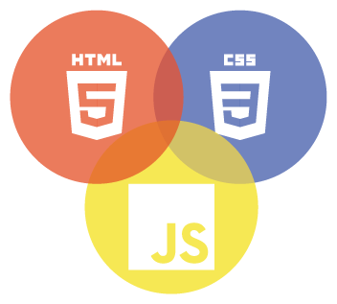

A React application's core elements are composed of CSS, HTML, and JavaScript. While CSS specifies how HTML elements should be visually presented and styled, HTML provides the framework and content[2]. By providing event processing, data manipulation, and API connectivity, JavaScript creates interactivity. React makes use of these essential web technologies and JSX, a syntax extension that combines HTML and JavaScript, to produce responsive, dynamic user interfaces and reusable UI components. Developers can use React to create complex and dynamic applications by fusing these components[6].

Backend Frameworks



Through the provision of a vast array of cloud-based services and tools, Firebase is a complete platform that streamlines the development of mobile and online applications. Developers may quickly set up backend functionality without maintaining servers or infrastructure thanks to its capabilities including real-time databases, authentication, hosting, cloud services, and storage[7]. Firebase seamlessly connects with a variety of platforms and frameworks thanks to its comprehensive APIs and SDKs. While the authentication service guarantees safe user authentication, its real-time database enables synchronised data updates. In addition, Firebase offers analytics and performance tracking tools for tracking application usage and locating potential development areas. Overall, Firebase gives developers the tools they need to easily build scalable, feature-rich applications.

# Chapter 6 : Methodology

## Project Management

This method overview explores the basic methods and practices used in the development and design phase of a cooking recipe website. Its main objective is to gain valuable insight into the strategies used to create an attractive and user-friendly platform that enables users to explore, share and discover a wide range of culinary recipes. By analyzing these approaches, the review seeks to understand how the site provides an engaging and seamless experience for cooks, enabling them to begin their culinary journey and fostering a vibrant community of foodies.

The cooking recipe website development process follows a structured methodology, starting with a requirements analysis to understand the needs of the target audience and users. Design and prototypes visualize the user interface using wireframes and prototypes. A careful selection of technology includes front-end frameworks React, Angular or Vue.js and back-end technologies ,Node.js or Ruby on Rails to optimize performance. The data model ensures efficient data management with databases such as MySQL, MongoDB or Firebase. Front-end and back-end development focuses on user-friendly user interfaces, secure data handling and smooth communication. Extensive testing ensures a flawless experience, and deployment in trusted cloud services such as AWS or Azure facilitates continuous integration for smooth updates.

In my approach to project management, I chose Trello and GitHub as my main tools because of their different benefits and features.

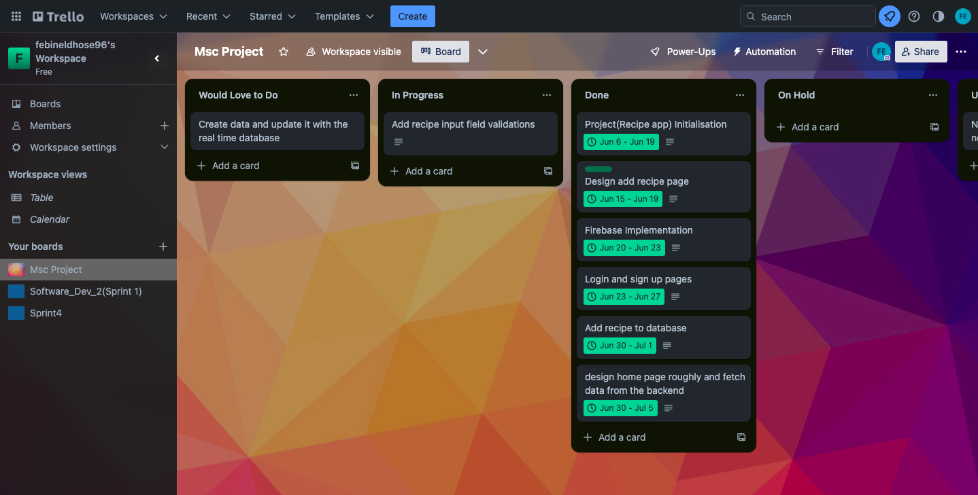

1.1 Trello Board

Trello's visually organized boards and user-friendly interface help you organize tasks, prioritize and track progress.

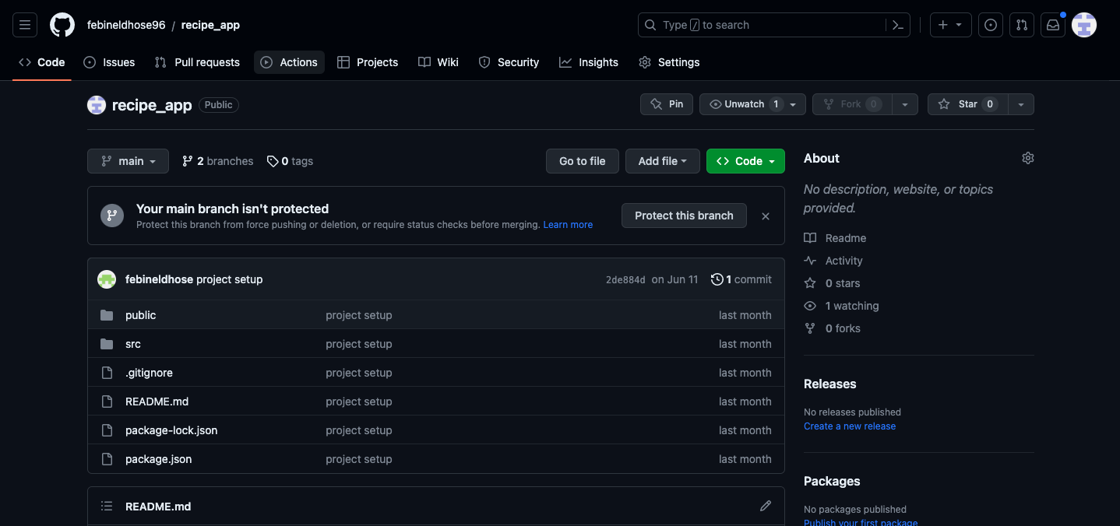

1.2 Github[3]

GitHub's version control and issue tracking encourages development collaboration and efficient code management. While I considered other tools like Asana, Jira, and Monday for their task management and team collaboration features, the seamless integration, popularity, and ease of Trello and GitHub in the development community make them optimal choices for a smooth and successful project management process.

Trello's visual boards provide a holistic view of tasks, allowing for easy categorization, prioritization and progress. Its user-friendly interface facilitates task sharing and team collaboration, which promotes effective communication between members.

On the other hand, GitHub's version control system provides seamless code management that allows for seamless collaboration between developers and easy change tracking. The issue tracking feature helps to quickly identify and resolve defects, which streamlines the development process. Considering options like Asana, Jira, and Monday, I felt their strengths in task management and teamwork. However, user-friendly interfaces, seamless integration, and popularity in the development community make Trello and GitHub ideal choices for my project.

By combining Trello's visual organization with GitHub's robust version control and issue tracking capabilities, I envision smooth and successful project management. These tools provide a clear view of tasks and progress, promote effective code management and ensure seamless collaboration, ultimately improving productivity, teamwork and project success.

**Table 1**

| **Project Report Delivery Schedule**  Note: Reorder the sections in the order that you plan to complete them. | Deadline Date |
| --- | --- |
| Introduction | 18-07-2023 |
| Literature - Technology Review | 22-07-2023 |
| Methodology | 20-07-2023 |
| Implementation and Results   * Evaluation * Related Work | 26-08-2023 |
| References | 30-08-2023 |
| Conclusion   * Reflection * Future Work | 26-08-2023 |
| Abstract | 28-08-2023 |
| Declaration | 28-08-2023 |
| Acknowledgements | 29-08-2023 |
| Appendices | 30-08-2023 |

**Table 2**

| **Artefact Delivery Schedule**  Note: Reorder the activities in the order that you plan to complete them. | **Deadline Date** |
| --- | --- |
| Artefact Planning and Resourcing | 30-07-2023 |
| Artefact Design | 24-08-2023 |
| Artefact Procurement Activities (e.g., data collection, source framework etc.) | 12-08-2023 |
| Artefact Development, Deployment, Implementation | 23-08-2023 |
| Artefact Evaluation and Testing | 30-09-2023 |
| Artefact Presentation and Demonstration | 06-09-2023 |
| Artefact Screencast | 08-09-2023 |

# Chapter 7 : Project Lifecycle

Numerous software techniques are employed to enhance output quality and efficiency.Two well-known techniques, the Waterfall model and the Agile model, exhibit opposing paradigms that influence project management and execution in the dynamic world of software development. These approaches represent several philosophies and strategies that are adapted to specific project requirements and organisational preferences. The Agile paradigm promotes adaptability and collaborative iteration, while the Waterfall model conforms to a linear, step-by-step framework. Understanding the complexities of these approaches is essential for making well-informed decisions that are in line with project goals and produce positive results in the face of changing dynamics in software development. Insightful perspectives into each model's advantages and disadvantages are provided by this comparison of the Waterfall and Agile models, making it easier to select the best approach for a given software development project.

7.1 Waterfall model

A traditional method for developing software, the waterfall model follows a linear process. The requirements gathering, system design, implementation, testing, deployment, and maintenance phases are divided into consecutive phases. Like the evolution of a cascade, each stage serves as the foundation for the following. The methodology, which is renowned for its thorough prior preparation and documentation, guarantees a well defined project scope, requirements, and outcomes[11].

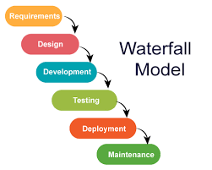

[figure take from JavatPoint]

Despite its simplicity and organisation, the Waterfall approach lacks adaptability to allow for changes in the middle of the process, which presents difficulties if requirements change or unforeseen problems arise. It flourishes in environments requiring meticulous planning, such as highly regulated industries, and its inflexible character makes it most ideal for projects with stable requirements. The Waterfall methodology is still useful in situations that prioritise predictability and good documentation, despite its limits in changing.

7.2.Agile methodology

The Agile methodology is a flexible, iterative way of developing software that emphasises teamwork, adaptation, and customer satisfaction. Agile divides projects into more manageable chunks known as sprints, in contrast to traditional methodologies[11]. Cross-functional teams work together to develop, test, and provide operational software components in this situation. Software is aligned with evolving requirements and user preferences thanks to regular feedback and iteration cycles. Agile encourages close developer-stakeholder communication, enabling quick adjustments and ongoing improvement.

Agile is based on concepts like valuing relationships, creating software that works, including customers, and giving change priority over set plans. This approach adapts well to changing priorities and unforeseen demands, flourishing in dynamic environments. It increases customer pleasure, emphasises frequent value delivery, and reduces the risks associated with protracted development delays. Agile equips teams to tackle problems and seize opportunities along the development journey by fostering open communication and adaptability.

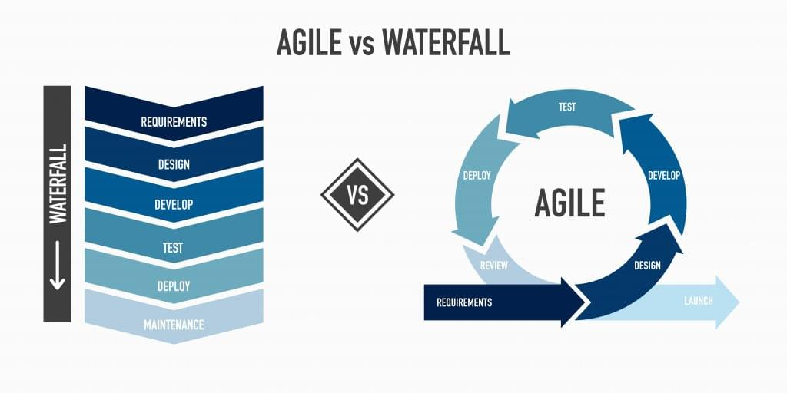 [figure from technology advice]

I have decided to use the Agile technique for software development after carefully comparing it against the Waterfall model. This choice is based on Agile's iterative, adaptive, and customer-focused attributes, which work well with the project's dynamic nature. Agile's focus on teamwork, quick feedback loops, and adaptability ensures a dynamic development process ready to meet changing needs and boost the likelihood of successful project outcomes.

## Plan stage

In the initial planning stage, I conducted thorough research to explore existing applications within the realm of my project and closely examined their limitations. My meticulous documentation of these limitations was driven by a desire to uncover unique areas where my app could excel. Through a comprehensive analysis of my app's features and functionalities in comparison to those of existing solutions, I was able to pinpoint distinctive value propositions and potential enhancements.

Given the memory-intensive nature and the imperative of high-performance optimization for my video recipe web application, I recognized the paramount importance of addressing these aspects. Subsequently, I formulated a well-defined strategy for the implementation phase, with a specific focus on effectively incorporating these critical elements. This involved a meticulous evaluation and selection of appropriate technologies capable of accommodating the substantial memory demands and performance requirements. Rigorous research was conducted to identify prevailing and relevant technologies that would best support the development process, ensuring optimal memory utilization and overall performance.

With the strategic foundation laid, the execution phase was initiated, centering on the actual implementation and coding process. During this stage, meticulous attention was given to the structure of the database to facilitate seamless data flow and to enable the delivery of optimal outcomes. As progress was made, the significance of gathering user feedback before the official release became evident. Consequently, a deliberate plan was devised to integrate a feedback section within the application. This strategic step was aimed at procuring invaluable insights directly from users, which would play a pivotal role in refining user experience, bolstering performance, and aligning the app more closely with their specific needs and expectations.

To ensure an informed direction, I opted for collaborative testing involving friends, affording me firsthand insights into user experiences, app performance, and the efficacy of the application in addressing their requirements. This thoughtful testing phase was strategically orchestrated to ensure that the app's functionalities resonate harmoniously with the intended user base, while effectively addressing any usability concerns that may arise.

In summary, my planning journey encompassed meticulous research, insightful comparison, strategic technological selection, thoughtful database structuring, and a proactive approach to gathering user feedback. These deliberate steps were undertaken with the overarching goal of developing a video recipe web application that distinguishes itself from existing solutions, offering users a personalized, high-performance, and rewarding experience.

## Design Stage

In the process of discussing topics within the planning stage, I accumulated valuable feedback. This led me to develop several design patterns for the recipe app, with the primary goal of ensuring effective visualization and alignment with user expectations.

## User persona

A user persona is a fictional representation of a certain target user group that captures their characteristics, propensities, behaviours, and goals. It assists in examining the subtleties of users and directs design and development decisions[12]. By creating user personas, developers and designers can better understand user needs and adjust properties and interactions to meet the expectations of the target user group. This method supports user-centric design by encouraging the development of goods that are more matched to the needs and preferences of the target market, ultimately leading to more relevant and attractive solutions.The figure 1 shows the user persona for cooking recipe website.

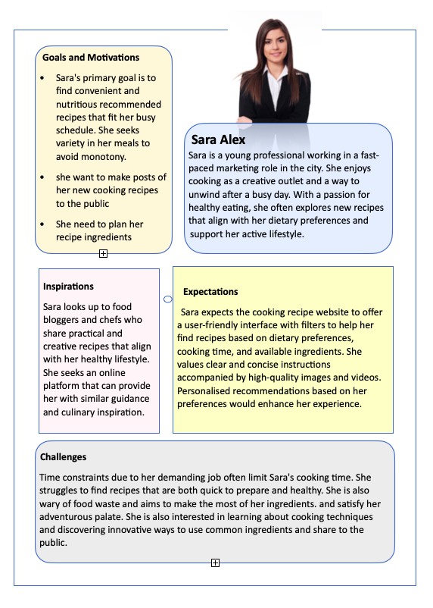

**Figure 1**

## User Journey Map

A user's interaction with a product or service is visually represented by a user journey map. It shows their behaviours, feelings, and interactions at different points and provides insights to improve and enhance the user experience.The below figure shows the depicted representation of user journey map for recipe website.

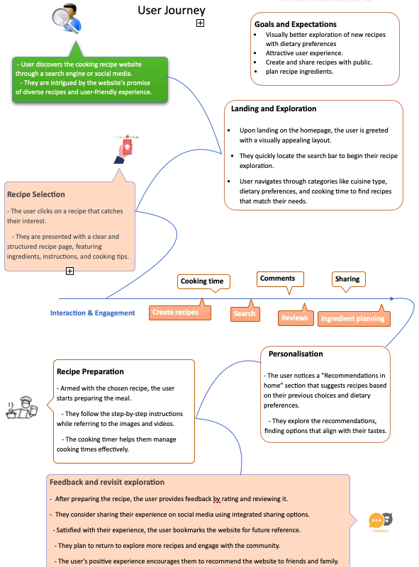

**Figure 2**

## User Stories

User stories are succinct descriptions of features or functionalities from the perspective of the user. They convey user requirements, justification, and predicted results[13]. User stories, which are expressed in plain language, make it easier for developers, designers, and stakeholders to communicate while ensuring a common understanding of user requirements and guiding the development process.The user story for recipe app is shown in the below figure.

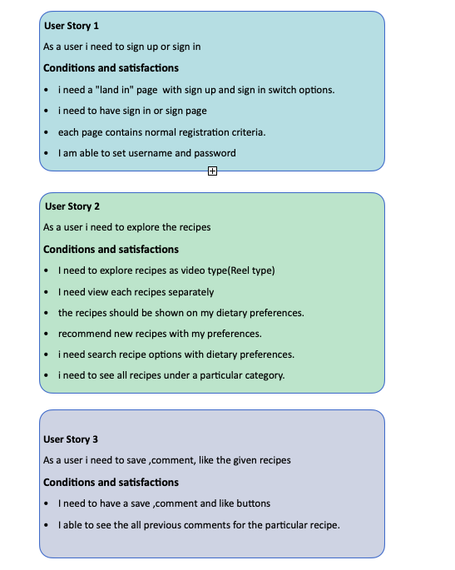

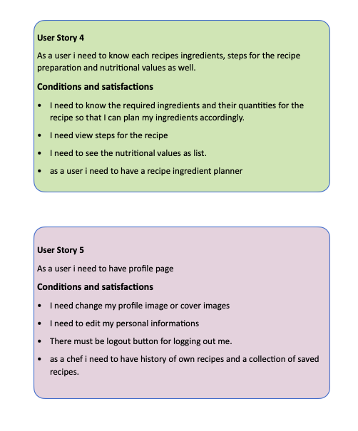

**Figure 3**

## Flow Diagrams

Flow diagrams provide a structured visual representation of the phases or processes' order[14]. They represent the flow of data, actions, or decisions using symbols and arrows, which makes it easier to understand and convey complex workflows or systems.The below figure will give a brief working of recipe web app in a flow diagram

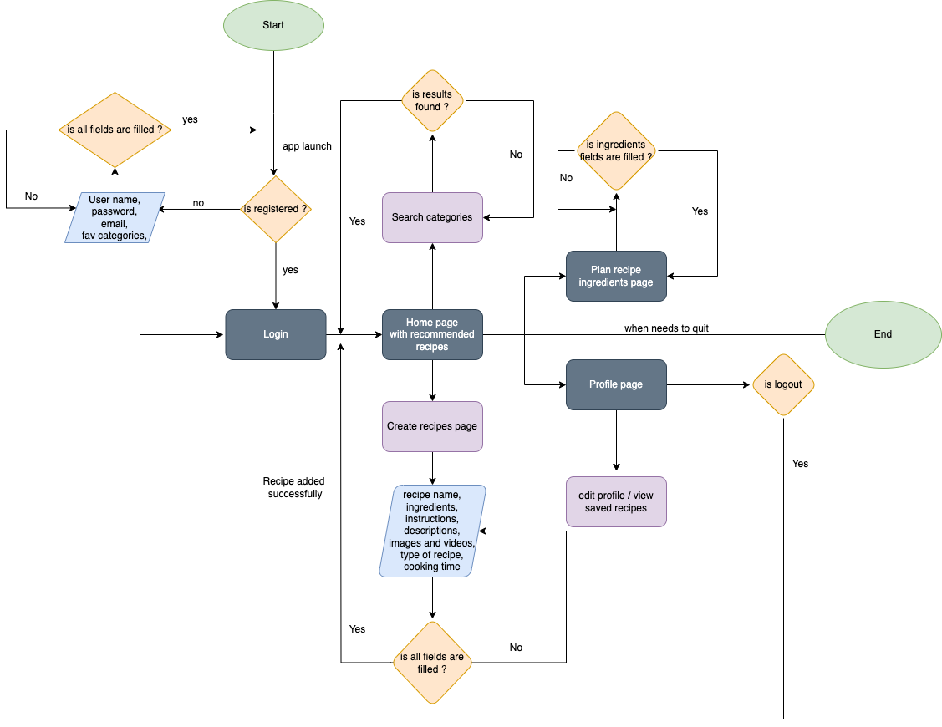

**Figure 4**

## WireFrames

Wireframes, which act as visual schematics to specify the layout of features like navigation, content sections, and user interface components in a website or app, are crucial tools in web development. They deliberately ignore details like colour schemes, typography, and visuals in favour of concentrating entirely on structure. During the early stages, these skeletal models are essential for designing design and functioning. Before the design and coding phases begin, wireframes facilitate open communication between designers, developers, and stakeholders, establishing a shared understanding of the project's layout and user experience.

Home Page

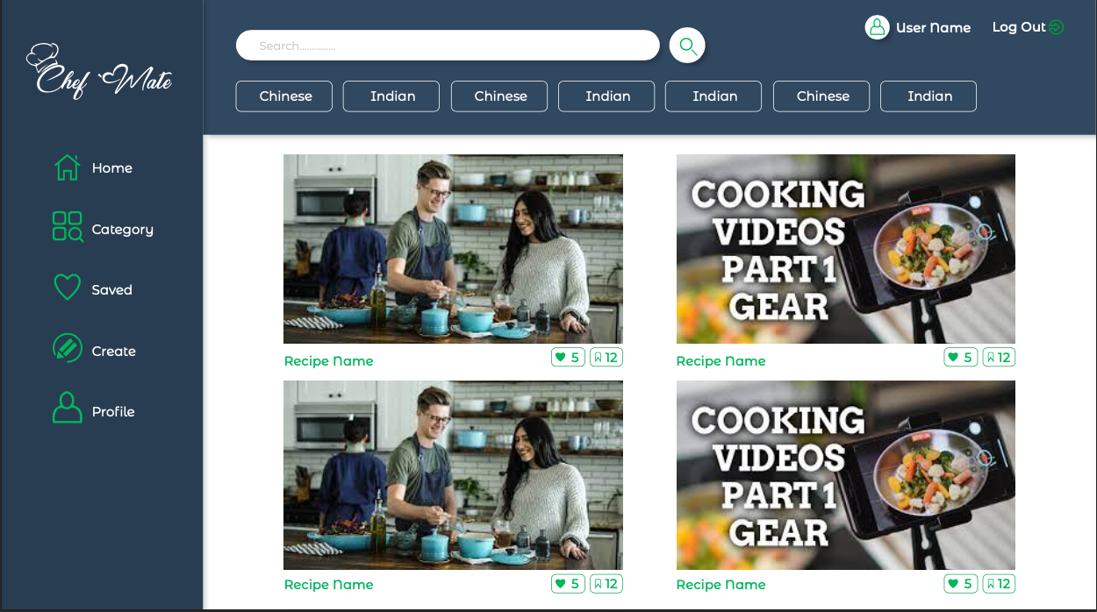

Recipe details

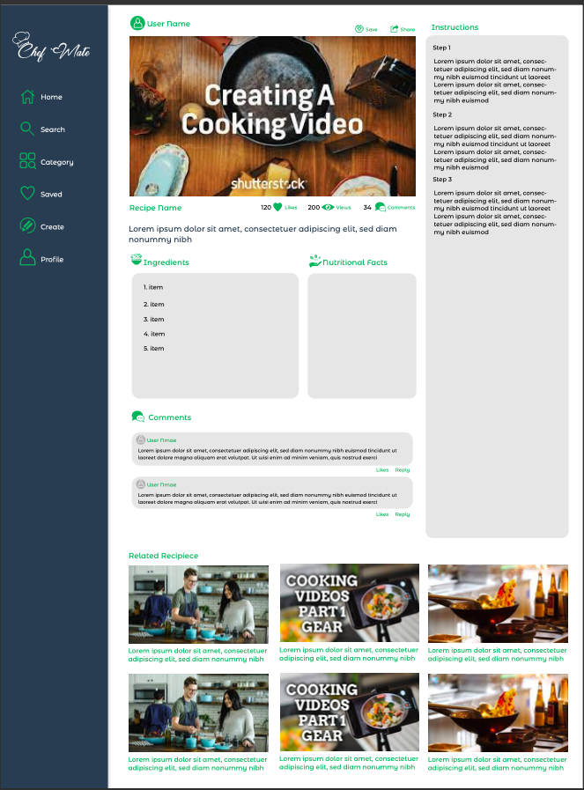

**Profile Page**

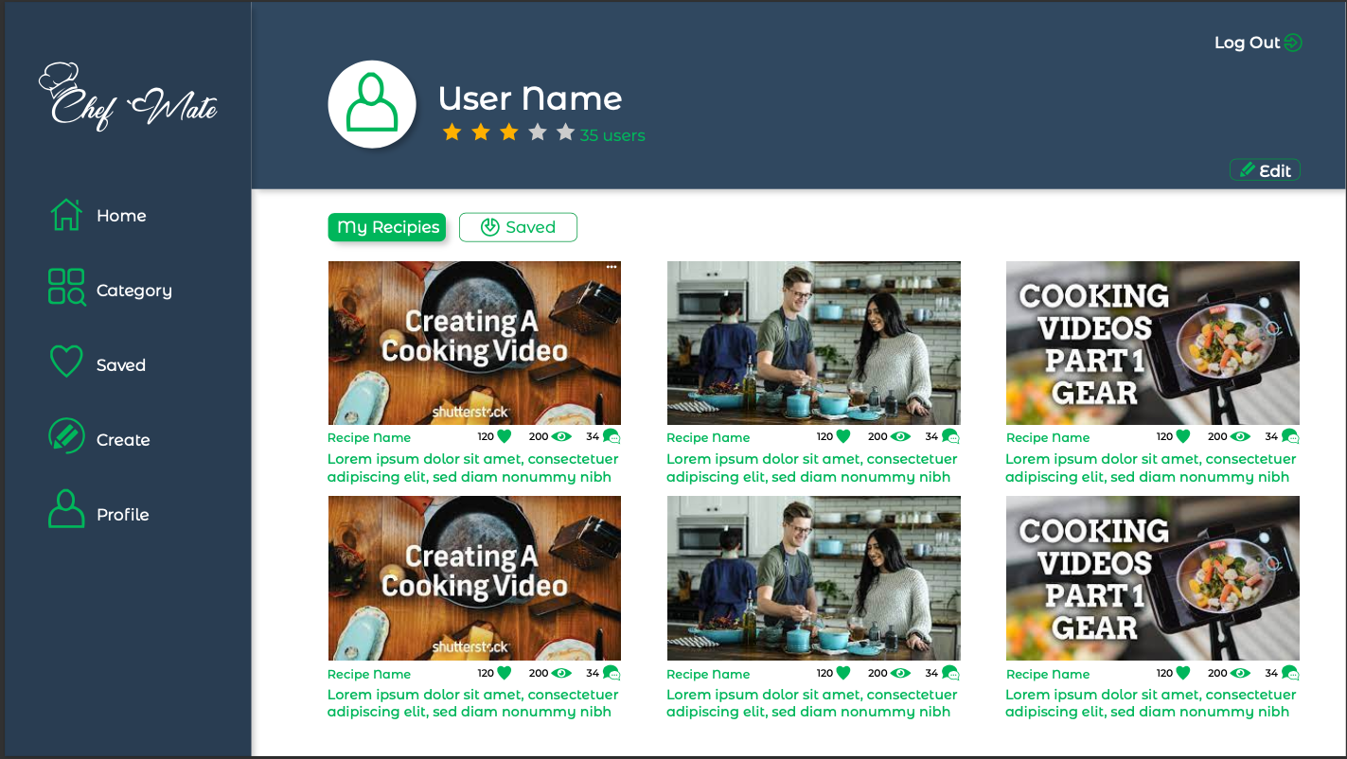

**Category Page**

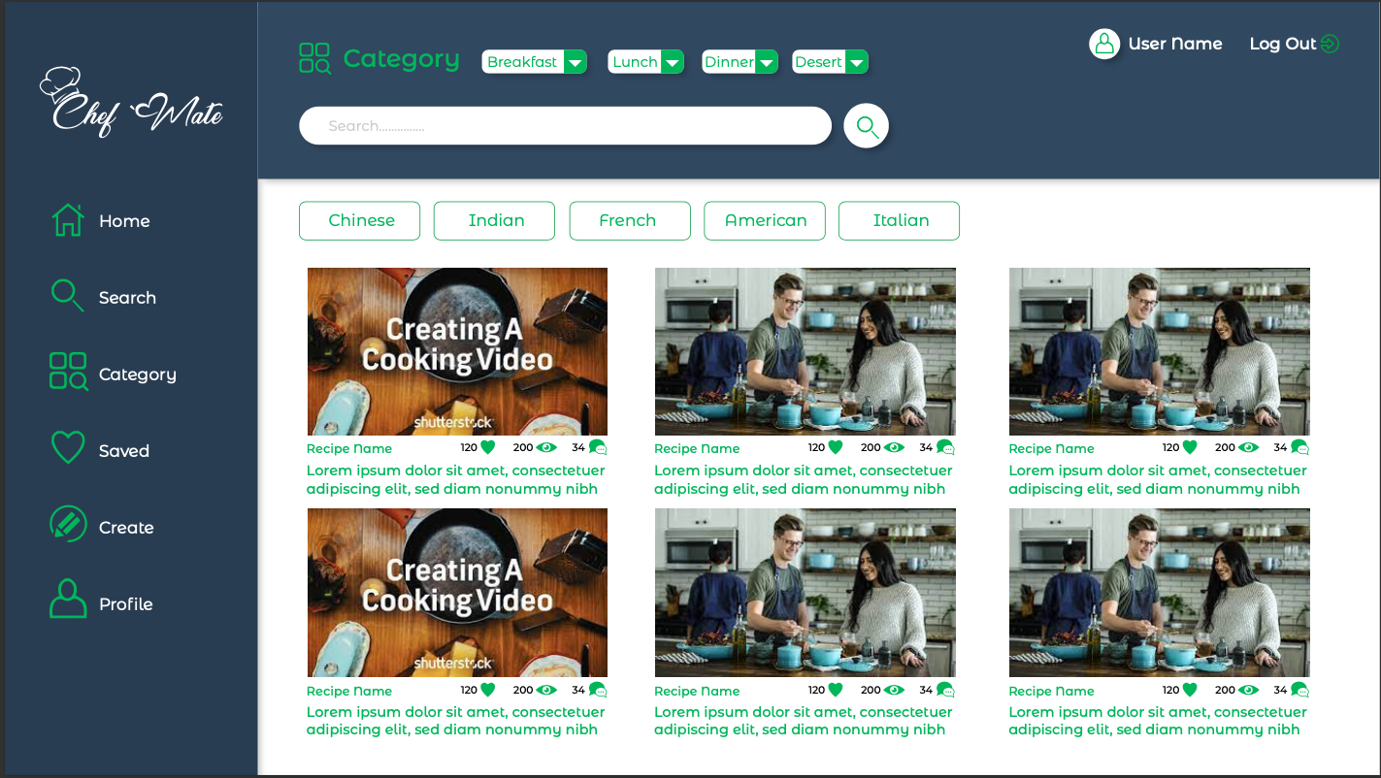

Database design

Real-time mobile and online apps are catered to by Google's Firebase Database, a cloud-hosted NoSQL database. It ensures seamless device synchronisation by using JSON data storage. Because of its real-time capabilities, linked clients are immediately informed of data changes. It has a user-friendly API for data access and modification and uses security rules to control rights. Firebase Database, which is widely used for building collaborative apps, chat platforms, and dynamic dashboards, frees developers from backend hassles so they can concentrate on creating interesting user interactions.The following figure shows the sample collection of databases used in firebase.

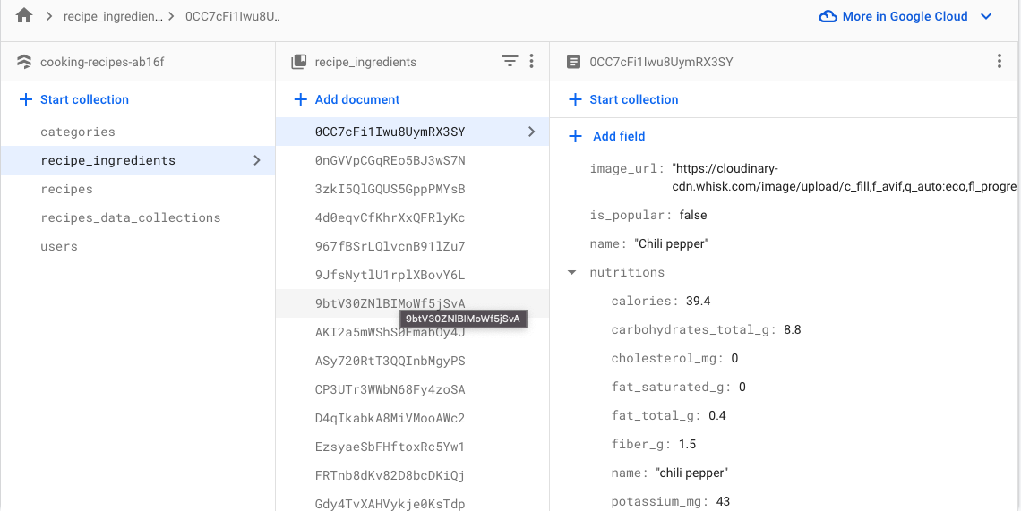

**Figure 5**

Implementation Stage

After successfully completing the design stage, my focus shifted to the development phase, where I immersed myself in coding the website. To achieve this, I chose to harness the capabilities of React, utilising the flexible nature of the JavaScript programming language. Leveraging React's component-based structure enabled me to create dynamic, interactive user interfaces that align with contemporary web standards.

For the backend framework, I made the decision to utilise Firebase, a robust and scalable platform offered by Google. Firebase's real-time database functionalities and user-friendly authentication system seamlessly matched my project's needs. This choice allowed me to prioritise crafting seamless user experiences without becoming entangled in complex backend intricacies.Throughout the coding process, Visual Studio Code emerged as an indispensable companion. Its comprehensive features, extensions, and user-intuitive interface streamlined coding activities, amplifying efficiency and enabling the translation of design concepts into functional code.

**Application designs**

**Landing Page**

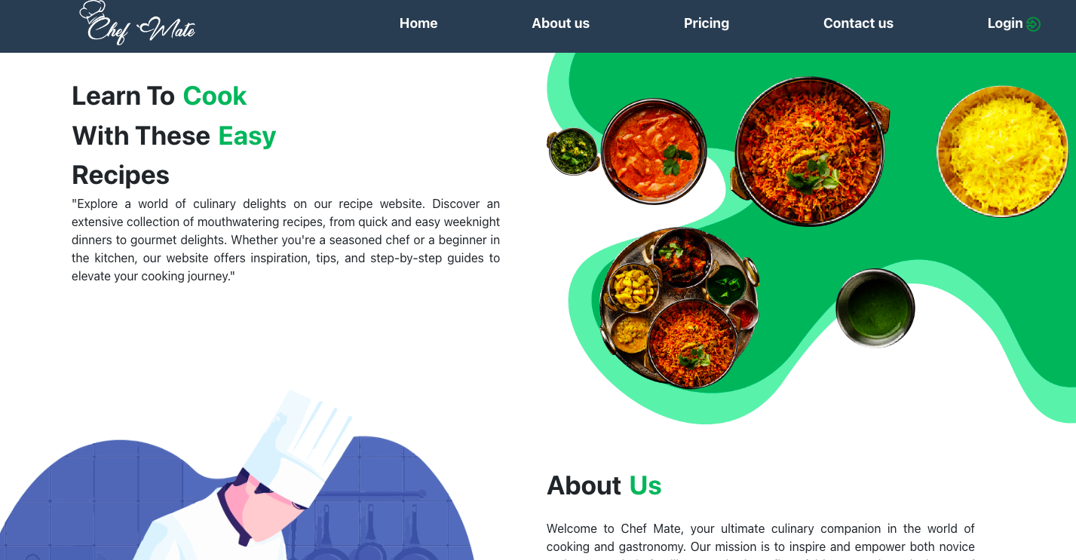

**Login Page**

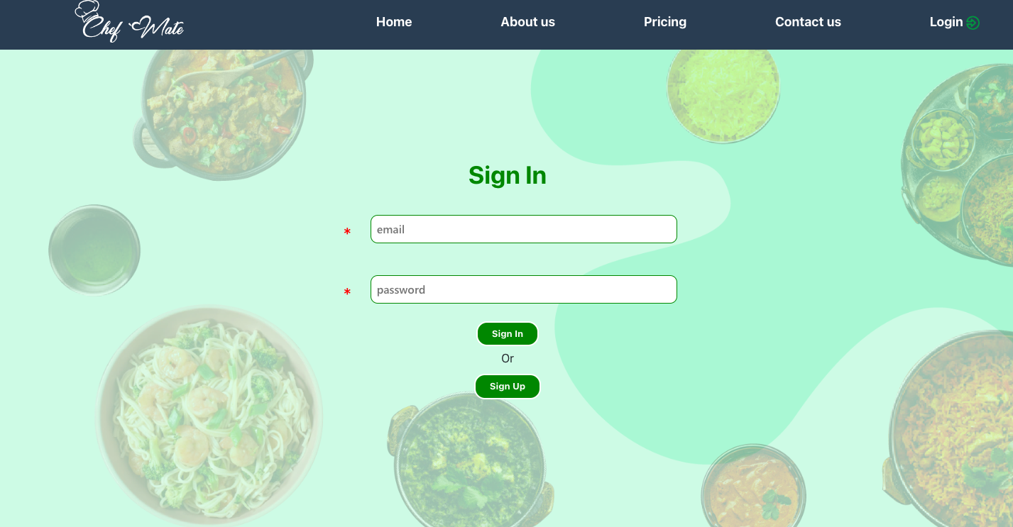

**Signup page**

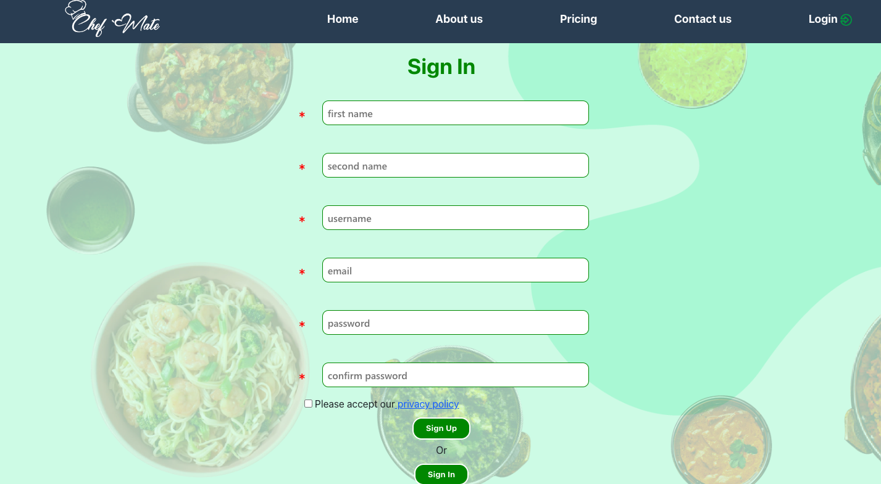

**Home Page**

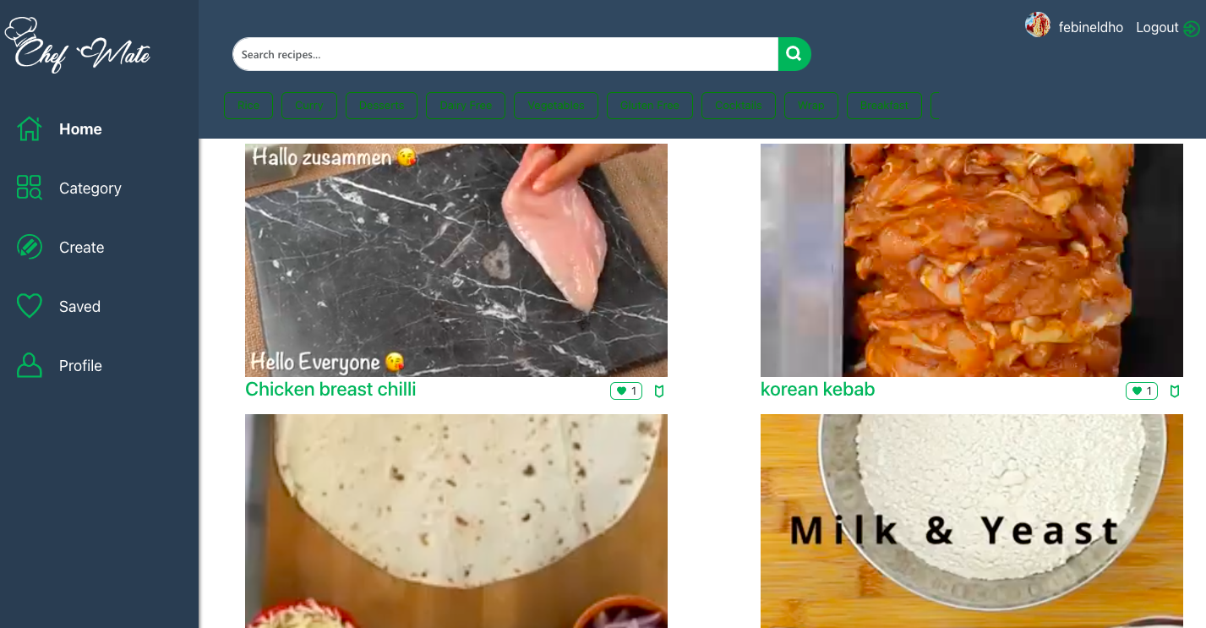

**Recipe Details Page**

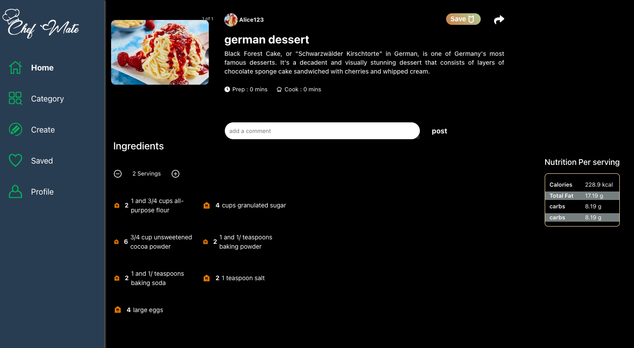

**Recipe Category Page**

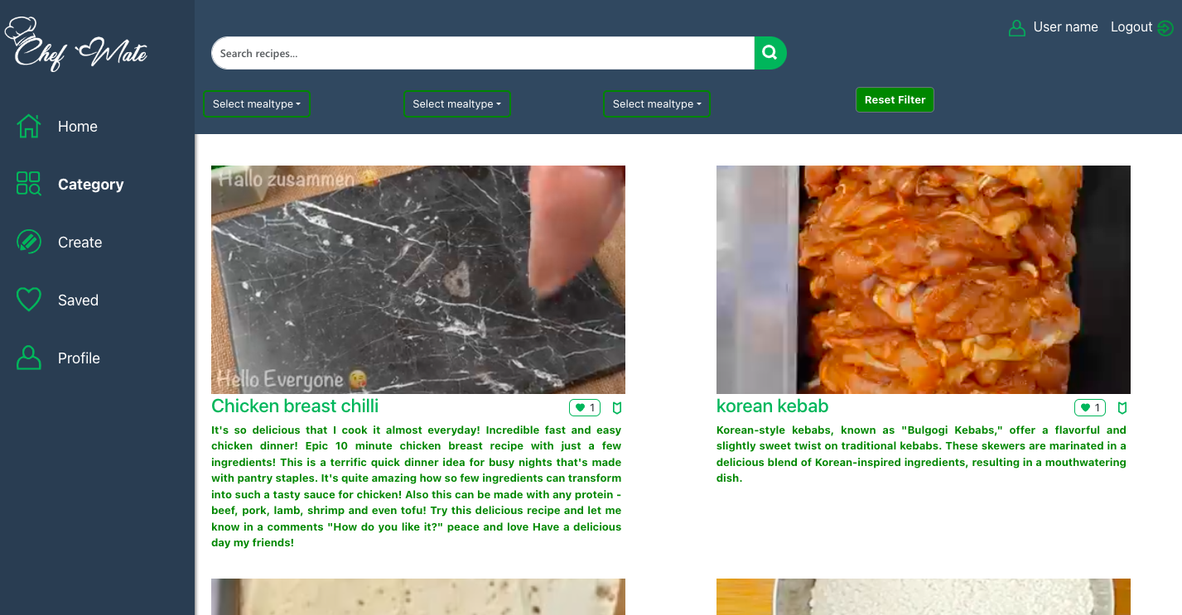

**Saved Recipes**

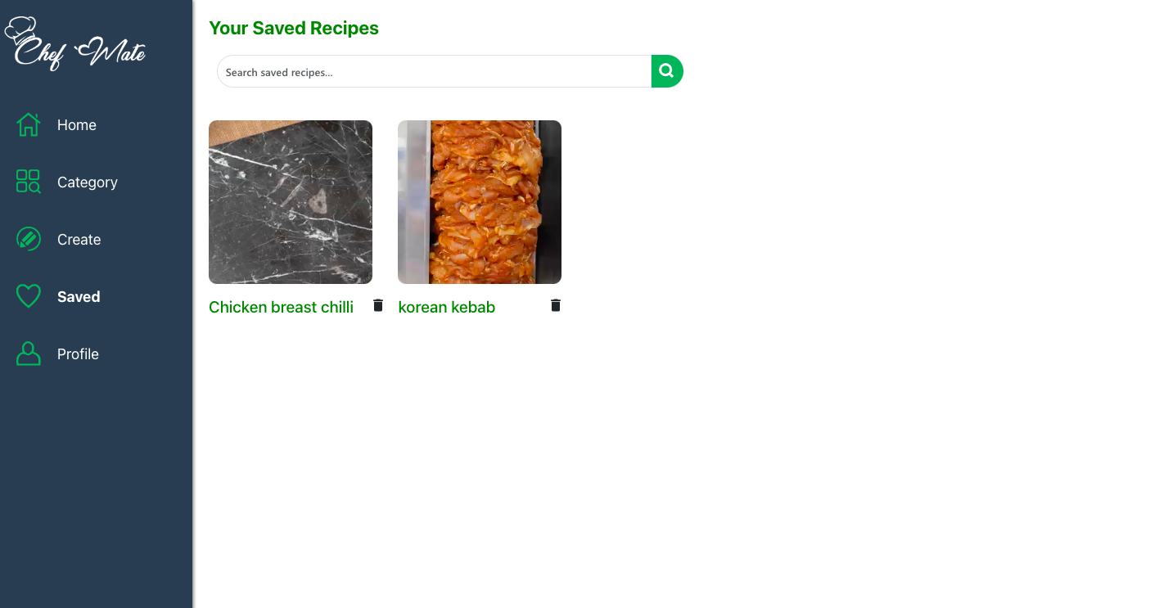

**Create Recipe Page**

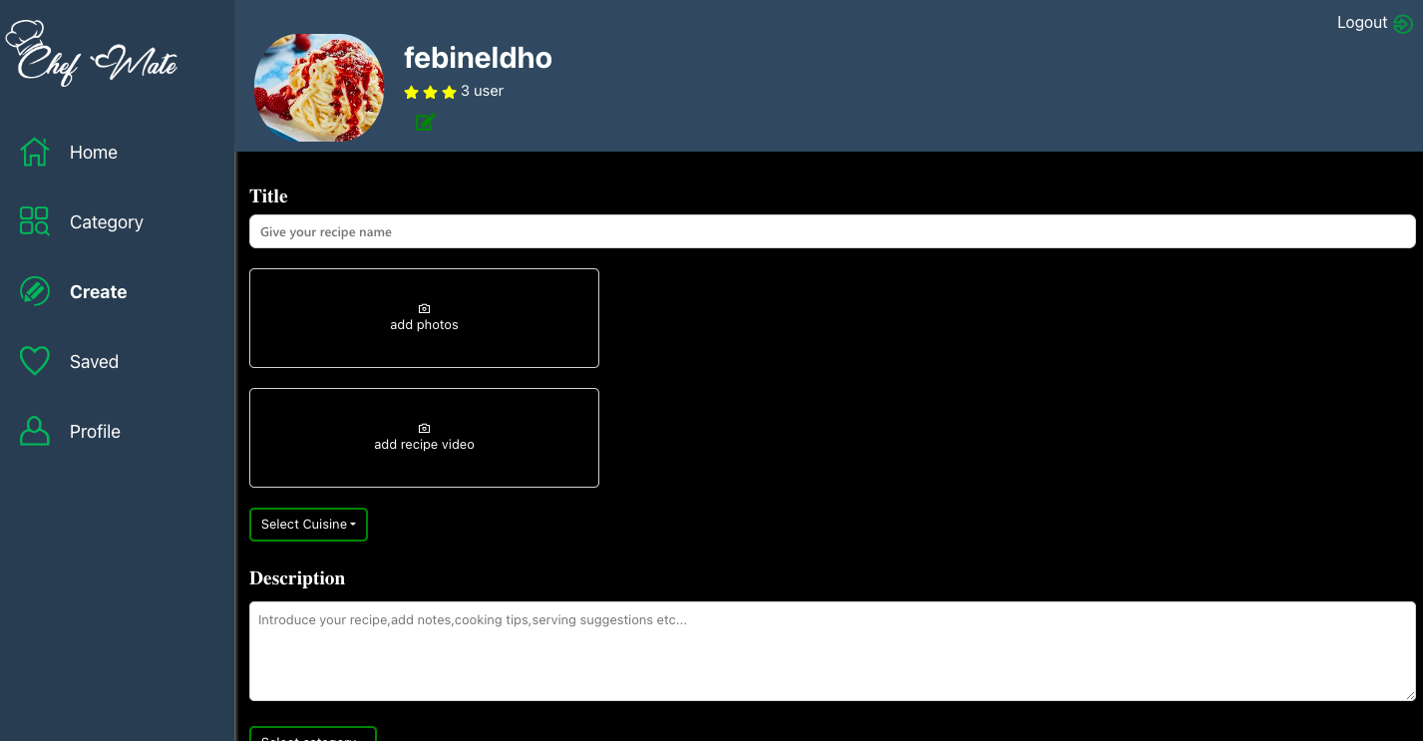

**User Profile Page**

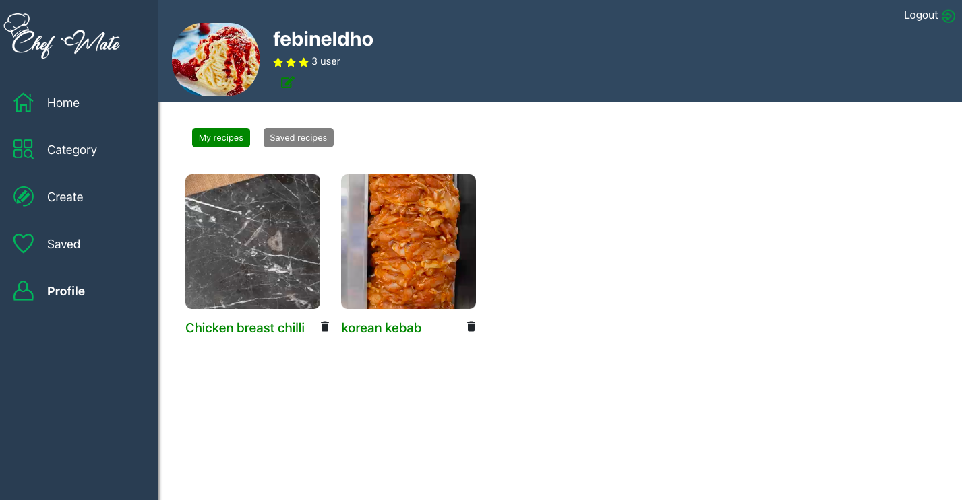

**Database design**

**User Database Collection**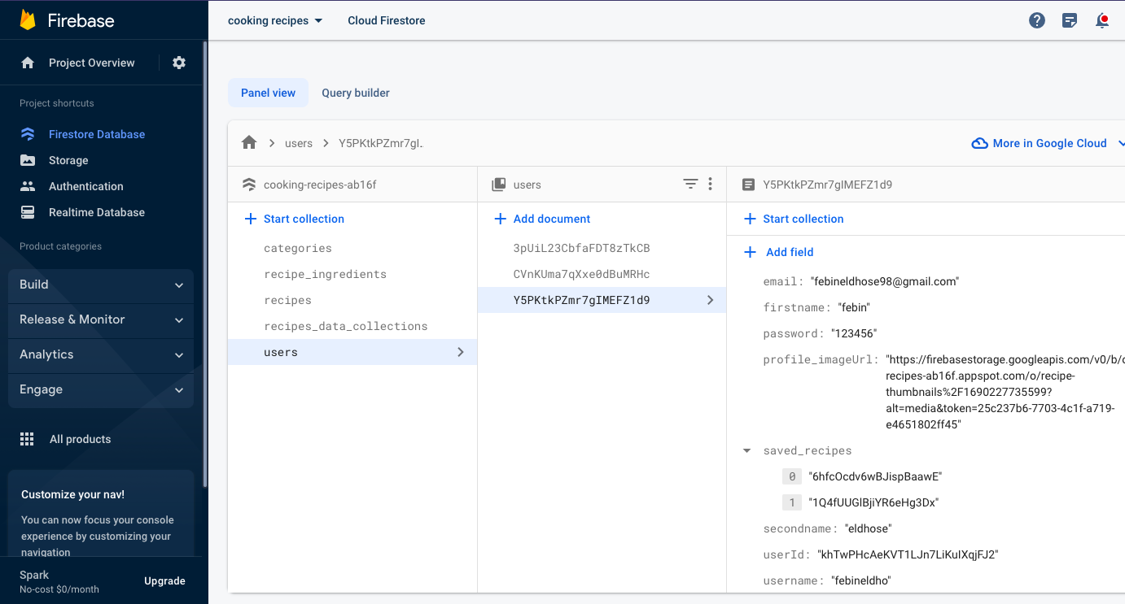

**Recipe categories collection**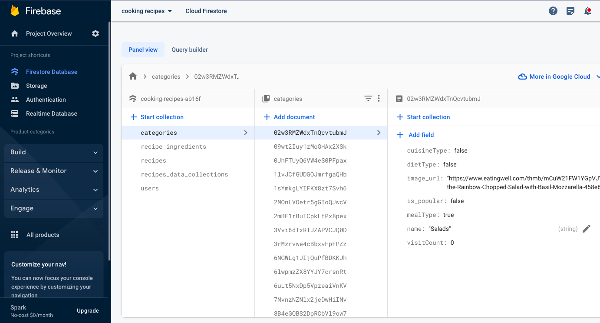

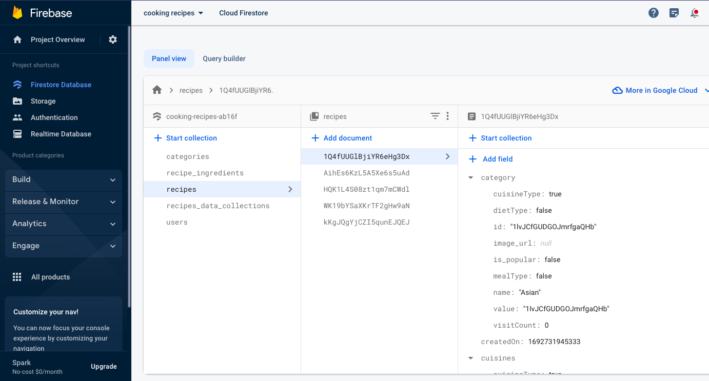

**Recipes Collection**

## Testing Stage

By seeing actual users interact with the platform, usability testing for a web application involves determining how user-friendly it is. Users' ability to navigate, complete activities, and engage with the system is evaluated. This method assists in identifying issues, improving user interfaces, and enhancing overall usability. The web app will match user expectations thanks to valuable insights learned from usability testing, creating a more effective and enjoyable digital experience.

**1. Usability Test 1**

This usability test was conducted on July 30th to assess the application's performance. However, during testing with my friends, it was discovered that when users scroll through each recipe reel, all the recipe reels play simultaneously.

Issue

1.playing all videos simultaneously

Solution

Users previously needed to scroll each time while watching, but I have implemented a method where the recipe reels only play when the mouse hovers over the top of the reels. This change has effectively resolved the issue.

Screenshot

# 

**2.Usability Test 2**

Problem

This test was conducted on August 15th, and it was observed that users were not receiving any dietary-specific suggestions on the home page, despite their stated dietary preferences.

Solution

I have implemented a feature where recommended dietary preferences are listed on the home page. Users can now click on any of them to receive corresponding dietary suggested recipes. This enhancement addresses the issue effectively.

Evidences

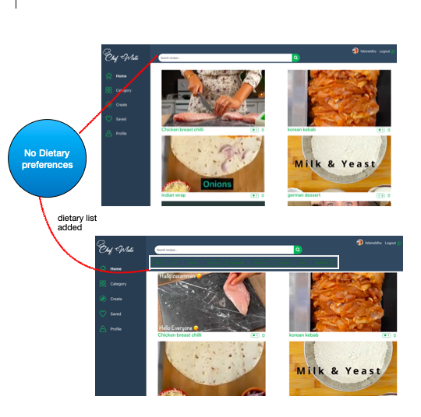

**3.Usability Test 3**

The test was conducted on August 22

**Issue**

Users currently lack the option to edit their profile pictures, which is a notable issue that needs to be addressed for enhanced user customization and engagement.

Solution

I've resolved the issue by introducing an "Edit" button on the profile page. Users can now easily update their profile images, enhancing customization and user interaction.

Evidence

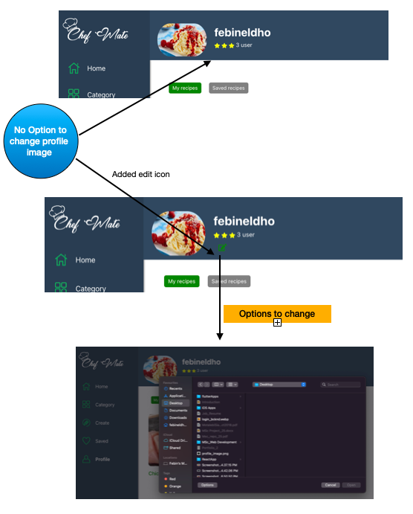

# Chapter 8 : Results

## Evaluation

Project evaluation is a critical aspect of website development, enabling the assessment of its impact and identifying areas for improvement. The primary project objective is to enhance recipe exploration, sharing, and planning through the integration of user-preferred suggestions. To achieve this, the implementation of a "Reel mode" is planned, offering engaging short video shots that pique user interest. Detailed recipe information will be accessible on a separate page, ensuring a seamless user experience.

However, during the implementation process, several challenges emerged. Firstly, the storage of video recipes demanded a significant amount of space. Secondly, uploading video-based recipes consumed more time, potentially affecting user engagement. Most notably, performance issues were encountered when loading recipes, compromising the site's usability.

The majority of users (89%) expressed a preference for the reels mode over reading the entire content. This preference stems from the engaging nature of visual content, allowing them to watch and witness the end results, which they found captivating and appealing.



Regarding personalised recommendations and ingredient planning, the ingredient plan implementation appears clear, while recommendations present some uncertainty. Further research is needed to refine the recommendation system to maximize its impact on users and enhance their experiences.

In conclusion, addressing the project's goals and challenges requires a focus on improving application performance and incorporating effective design techniques for an enhanced user interface. Additionally, finding solutions to the spacing issues that arose during development will be crucial. Through thorough research and iterative improvements, the website can provide users with a seamless and enjoyable recipe exploration and planning platform, enriching their culinary experiences.

**Related Works**

Numerous comparable websites such as One Whisk and Simply Recipes exist for exploring cooking recipes. Drawing inspiration from these platforms, I integrated features like recipe creation, preparations, ingredient planning, and recommendation systems into my website. The differentiating factor lies in the utilisation of reels mode, employing video content that enhances user engagement, setting my platform apart from the rest.

Whisks home page covers almost every recipes with user preferences.but only in the form of images

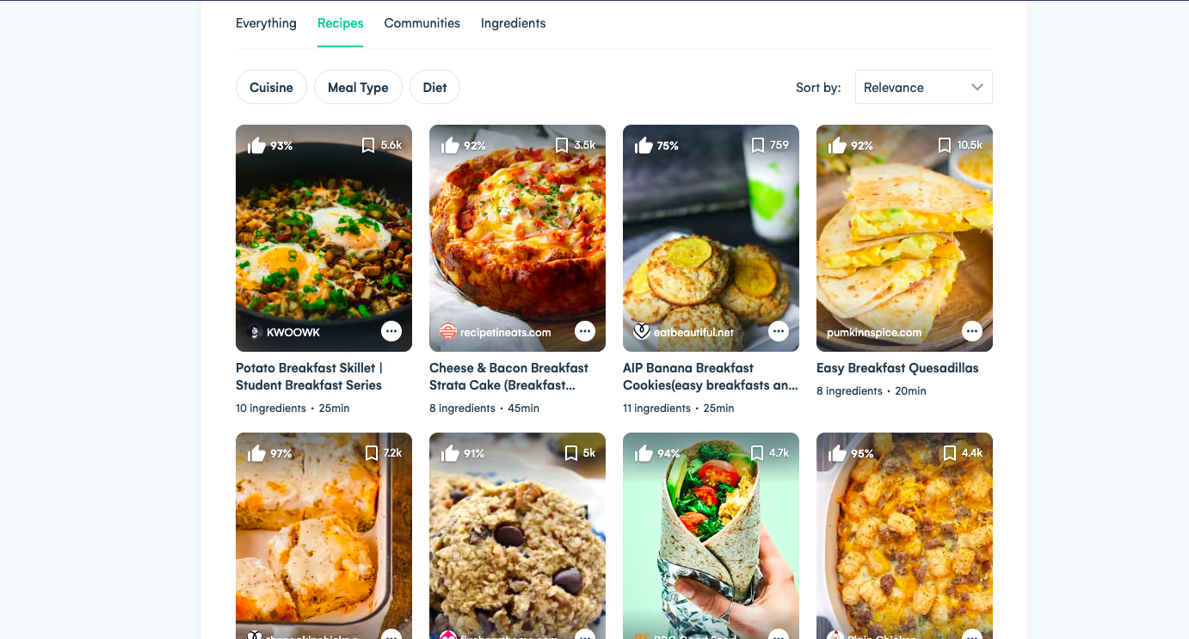

In contrast to similar platforms like One Whisk and Simply Recipes, my website offers a unique blend of features. Users can explore recipes both through video mode and individual pages presenting comprehensive creation content, including videos and images. This dual approach ensures versatility, catering to diverse user preferences. Video mode enhances engagement, providing an immersive experience that captivates users and sets my platform apart as an engaging and comprehensive recipe resource.

# Chapter 9 : Conclusion

I have achieved a significant milestone with the successful completion of my inaugural website. This journey was marked by formidable challenges, encompassing a lack of proficient coding skills and grappling with unfamiliar applications of JavaScript within the React framework. At times, coding with CSS posed substantial difficulties. My journey in full-stack development demanded substantial expertise in database management, a task I undertook using Firebase. The intricacies of database handling posed significant challenges, but through iterative coding, rigorous testing, and diligent research, I managed to surmount these obstacles.

The process was characterized by continuous learning and refining my coding skills. Overcoming hurdles necessitated persistent efforts, and each obstacle became an opportunity for growth. The ability to navigate these challenges culminated in the 80% successful completion of a fully functional application. While the journey was riddled with complexities and many bugs, it ultimately reinforced the value of perseverance, research, and a willingness to adapt. The outcome reflects not only the technical aspects but also the personal growth and resilience gained through the demanding yet rewarding process of website development.

## Reflection

The creation of the culinary recipe website has been a remarkable journey of discovery, learning, and growth. This project has given me priceless insights into the fields of design, development, and user interaction from its conception to completion. As I think back on this project, I'm struck by how iteratively it developed; my original idea changed as I learned more about user preferences and struggled with complex technological solutions.

The importance of user-centric design is a key lesson learned from this endeavour. It was necessary to do thorough research and make wise decisions in order to design the website to satisfy the diverse needs and preferences of users. The incorporation of video content, the approachable recipe exploration interface, and personalised recommendations were all inspired by the desire to create a simple, engrossing experience that really appeals to foodies.

Technically speaking, this journey has pushed me beyond my limits. Coding issues need strong resolve and relentless work to overcome, particularly when dealing with React and CSS. It was challenging and rewarding to navigate Firebase's complex environments when managing databases. Continuous testing and iterative coding were essential for maintaining a smooth user experience and improving functionality.

In hindsight, this project represents more than just the creation of a website; it also serves as an example of resourceful problem-solving, innovative creativity, and steadfast determination. It highlights the marriage of technical skill with user empathy, demonstrating how successful web development successfully fuses functionality and meaningful involvement. Beyond only the lines of code, the delight in the finished result comprises the voyage itself, a transformational passage that has strengthened me with abilities and insights for future initiatives.

## Future Work

There are some features are in my mind to implement,

1.Automated Advanced Recommendations:These suggestions are produced using cutting-edge personalised technology that makes use of user search data and Google Analytics insights. The system improves its recommendations by examining user behaviour and preferences, giving users a more personalised and pertinent experience.

2.Ingredient planner:Advanced ingredient planning with help of AI platform by analysing the recipe ingredients automatically.

3.Recipe status:Each user can post the recipe images or videos as personal status.

4.Community Chat: Each user can chat with the community with their doubts and interests.

5.There are lot of bugs were need to find by proper testing and then improve the application performance.

# References

[1] Angular.io, Angular Documentation'. [Online]. Available: https://angular.io. [Accessed: July- 2023]

[2] ReactJS.org,’ ReactJS official'. [Online]. Available: http://www.ReactJs.org. [Accessed: July- 2023]

[3] Github.com, ‘Git Documentation'. [Online]. Available: https://github.com/facebook/react. [Accessed: July- 2023]

[4] Top web technologies,[online].Available: https://medium.com/javarevisited/top-5-programming-languages-for-web-development-in-2021-f6fd4f564eb[Accessed: July 2023].

[5] visualstudio.com, ‘visual studio doc'. [Online]. Available: https://code.visualstudio.com/ [Accessed: July- 2023]

[6] w3schools,'react docs reference'.[online] Available:https://www.w3schools.com/[Accessed:July-2023]

[7] firebase, 'firebase docs',[online].Available:https://firebase.google.com/[Accessed: July- 2023]

[8] https://international.binus.ac.id/computer-science/2020/11/03/definition-and-history-of-recommender-systems/#:~:text=The%20first%20implementation%20of%20the,Tapestry%2C%20the%20first%20commercial%20RS.

[9] w3schools,HTML and CSS docs reference'.[online] Available:https://www.w3schools.com/[Accessed:July-2023]

[10] https://research20atimperial.wordpress.com/compulsory-content/legal-ethical-issues/

[11]https://technologyadvice.com/blog/information-technology/what-is-agile-project-management/

[12]https://miro.com/persona/what-is-a-user-persona/?gclsrc=aw.ds&

[13] https://www.atlassian.com/agile

[14] https://en.wikipedia.org/wiki/Flow_diagram

Cooper, A., Reimann, R., Cronin, D.: About Face 3: The Essentials of Interaction Design. Wiley, Indianapolis (2007)

S. Alcic and S. Conrad. Page segmentation by web content clustering. In *Proceedings of the International Conference on Web Intelligence, Mining and Semantics*, WIMS "11, pages 24:1--24:9, New York, NY, USA, 2011.

Stankovic, John. "Research directions for the internet of things." Internet of Things Journal, IEEE 1.1 (2014): 3-9.

Y. Akazawa and K. Miyamori. Cooking recipe search system considering food materials In Proc. the 3rd Forum on Data Engineering and Information Management, 2011 (in Japanese).

Micheal G.christel:,Automated Metadata in Multimedia Information Systems:Creation,Refinement,Surrogation and Evolution, 2009

Doherty, W.: An analysis of multiple factors affecting retention in Web-based community college courses. Internet Higher Educ. 9(4), 245–255 (2006).

P. Bedi, H. Kaur, and S. Marwaha. Trust based recommender system for semantic web. In IJCAI 07: Proceedings of International Joint Conferences on Artificial Intelligence, pages 2677--2682, 2007.

Edwards-Stewart, A., Alexander, C., Armstrong, C. M., Hoyt, T., & O'Donohue, W. (2019). Mobile applications for client use: Ethical and legal considerations. *Psychological Services, 16*(2), 281–285

Gao et al., 2019.X. Gao, F. Feng, X. He, H. Huang, X. Guan, C. Feng, …, T.-S. Chua

Hierarchical attention network for visually-aware food recommendation ,IEEE Transactions on Multimedia, 22 (2019), pp. 1647-1659

Gao et al., 2022.X. Gao, F. Feng, H. Huang, X.-L. Mao, T. Lan, Z. Chi,Food recommendation with graph convolutional network ,Information Sciences, 584 (2022), pp. 170-183.

Toledo et al., 2019.R.Y. Toledo, A.A. Alzahrani, L. Martinez,A food recommender system considering nutritional information and user preferences,IEEE Access, 7 (2019), pp. 96695-96711

Trattner and Elsweiler, 2017.Trattner, C., & Elsweiler, D. (2017). Investigating the healthiness of internet-sourced recipes: implications for meal planning and recommender systems. In *Proceedings of the 26th international conference on world wide web, Perth, Australia* (pp. 489-498).

Rostami et al., 2022.M. Rostami, U. Muhammad, S. Forouzandeh, K. Berahmand, V. Farrahi, M. Oussalah

An effective explainable food recommendation using deep image clustering and community detection,Intelligent Systems with Applications, 16 (2022), Article 200157

Pecune et al., 2020.Pecune, F., Callebert, L., & Marsella, S. (2020). A Recommender System for Healthy and Personalized Recipes Recommendations. In *HealthRecSys@ RecSys* (pp. 15-20).

Forouzandeh et al., 2020.S. Forouzandeh, K. Berahmand, M. Rostami,Presentation of a recommender system with ensemble learning and graph embedding: A case on MovieLens ,Multimedia Tools and Applications (2020)

Deldjoo et al., 2021.Y. Deldjoo, A. Bellogin, T. Di Noia,Explaining recommender systems fairness and accuracy through the lens of data characteristics,Information Processing & Management, 58 (2021), Article 102662

Yao et al., 2018.L. Yao, Q.Z. Sheng, X. Wang, W.E. Zhang, Y. Qin,Collaborative location recommendation by integrating multi-dimensional contextual information,ACM Transactions on Internet Technology (TOIT), 18 (2018), pp. 1-24

Zhang et al., 2021.Q. Zhang, J. Lu, Y. Jin,Artificial intelligence in recommender systems

Ruffo and Schifanella, 2009.G. Ruffo, R. Schifanella,A peer-to-peer recommender system based on spontaneous affinities,ACM Transactions on Internet Technology (TOIT), 9 (2009), pp. 1-34

Choo, S., & Park, J. (2020). Analysis of Usability Factors Affecting User Satisfaction in Cooking Recipe Applications. Sustainability, 12(14), 5672.

Chen, Y., Zhang, X., Xu, W., & Xie, H. (2019). An Intelligent Personalized Recommendation System for Cooking Recipes. In Proceedings of the 25th ACM SIGKDD International Conference on Knowledge Discovery & Data Mining (pp. 2375-2384).

Salmon, C. T. (2018). Social interactions and user engagement with recipe websites. Appetite, 123, 231-240.

Danciu, C., Kotnik, P., Fuchsberger, V., & Tscheligi, M. (2017). Cooking with the Crowd: Exploring the Benefits and Limitations of Crowdsourcing for Recipe Authoring. In Proceedings of the 2017 CHI Conference Extended Abstracts on Human Factors in Computing Systems (pp. 2496-2503).

# Appendix

## GitHub Link

**Link to my repo**: <https://github.com/febineldhose96/recipe_app>

Sample github code repo screenshot

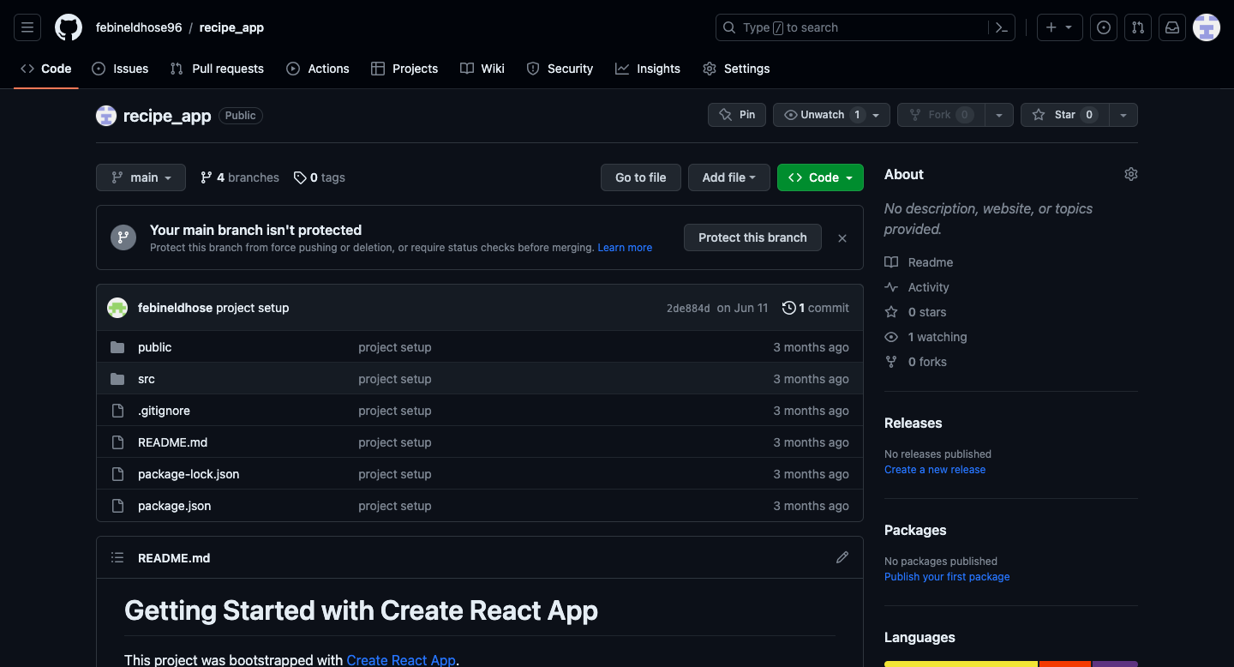

## Trello Board Link

Link to my task board : <https://trello.com/b/vGqNTx37/msc-project>

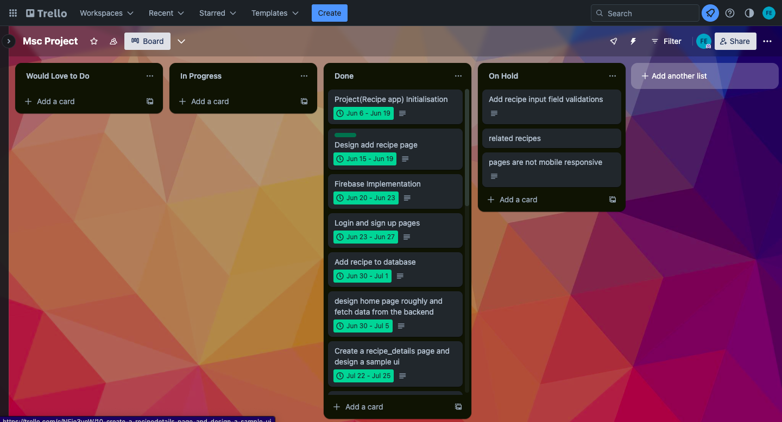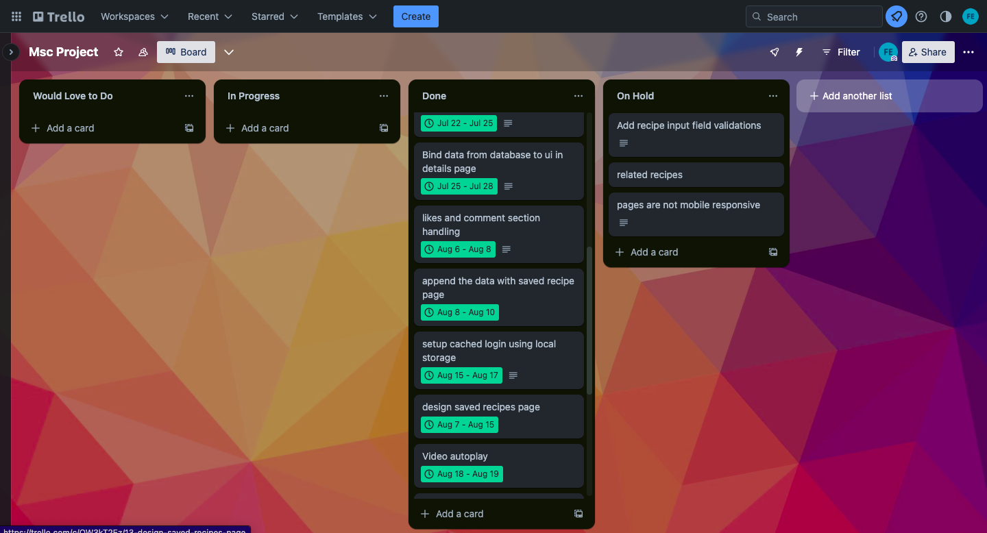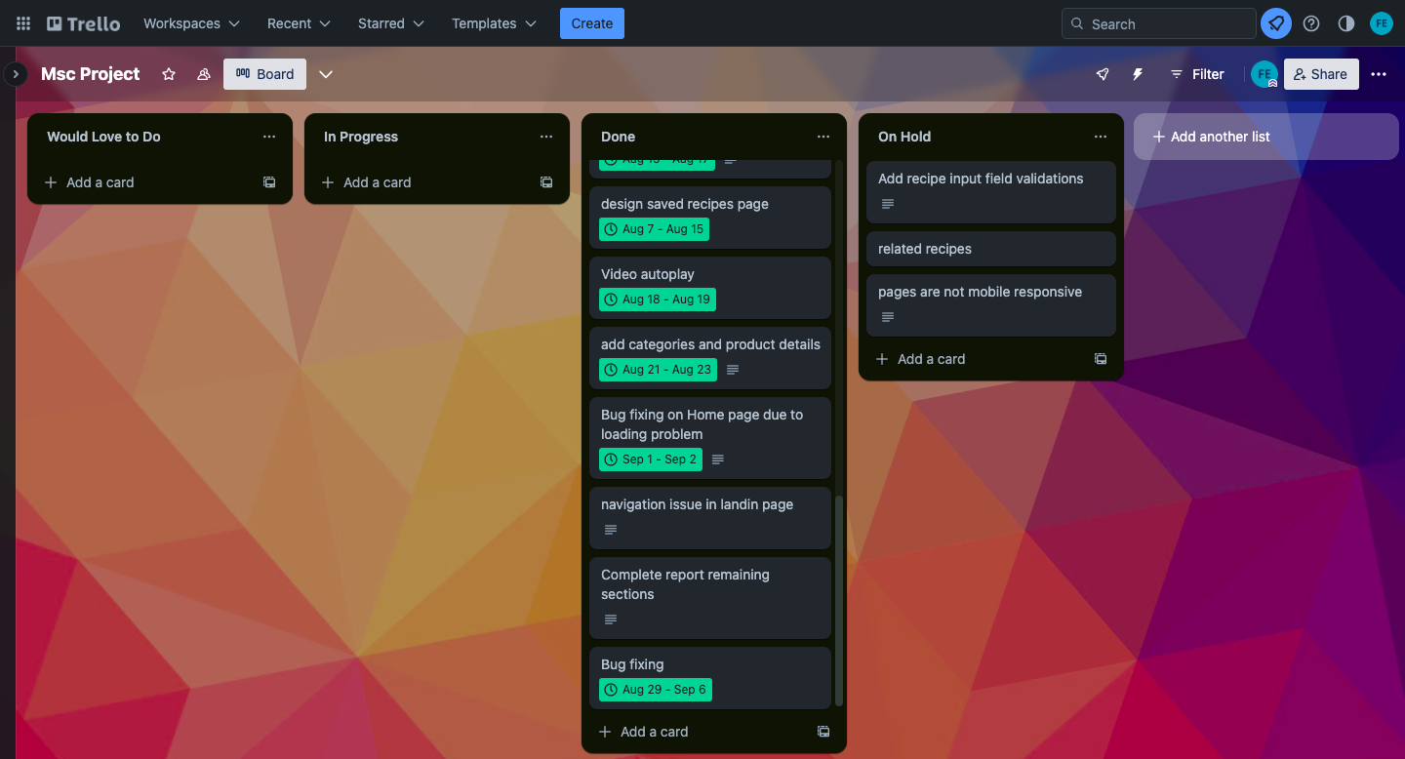

## 

## 

## 

## 

## 

## 

## 

## 

## 

## 

## 

## 

## 

## 

## 

## 

## 

## Meetings Feedbacks

